MITIH Createch Ecosystem report

Prepared for Salford City Council by The Fifth Sector and Obsolete.com

March 2025

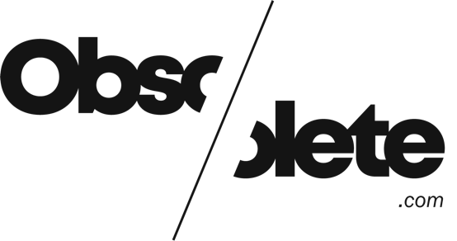


1. EXECUTIVE SUMMARY 1
1.1 Demand Is not the same as resilience 1
1.2 The Network Is under-activated 1
2. INTRODUCTION 2
3. CONTEXT: THE CURRENT LANDSCAPE AND CHALLENGES 3
4. FINDINGS 6
4.1 Scale and significance of the sector 6
4.2. Creative Industries and Createch Employment 11
4.3 Changes in demand for skills 13
4.4 R&D capacity 16
4.5 Innovation flows: myth vs reality 17
4.6 Suggested policy shifts 18
4.7 Reframing narrative for MITIH and beyond 19
4.8 Policy alignment 19
5. SOCIAL NETWORK ANALYSIS 20
5.1. Benefits of social network analysis 23
5.2 Limitations of SNA 23
5.3. Overall network findings 24
5.4. Community analysis 24
5.5 Network density 29
5.6 Very small community memberships 30
6. FUTURE-FACING SKILLS IN GREATER MANCHESTER’S CREATIVE-DIGITAL ECONOMY (2020–2024) 31
6.1 Communication and agile thinking are ubiquitous 31
6.4 Implications for university partners 33
7. ECOSYSTEM RESILIENCE AND LABOUR MARKET DEMAND 34
7.1 Animation: active but isolated 34
7.2 Audio: present, but drifting toward obsolescence 35
7.3 Studio Production: a hidden mesh layer 35
7.4 Synthesis: sector health vs network resilience 36
7.5 Strategic recommendations 36
8. CURRICULUM-TO-COLLABORATION: ALIGNING TALENT PIPELINES WITH ECOSYSTEM NEED 37
Purpose 37
8.1 Labour market signals: what employers are asking for 37
8.2 Sector readiness for collaboration 38
8.3 Curriculum recalibration recommendations 38
8.4 From teaching to participation: structural suggestions 39
8.5 Strategic rationale 40
8.6. Summary 40
9. HIDDEN INFRASTRUCTURE: SURFACING THE UNDER-RECOGNISED ASSETS IN ANIMATION, AUDIO AND STUDIO PRODUCTION 41
9.1 What do we mean by hidden infrastructure? 41
9.2 Roles in demand but strategically ignored 41
9.3 Network roles missing from strategy 42
9.4 The strategic value of hidden infrastructure 42
9.5 Intervention ideas: how to support it properly 42
9.6 Reframing value: from shadow workers to strategic assets 43
9.7 Recommendation summary 43
10. RESILIENCE READINESS CANVAS: ANIMATION, AUDIO & STUDIO PRODUCTION 44
10.1 Sector overview 44
10.2 Labour market signals 44
10.3 Risks of exposure to automation 45
10.4 Social Network Analysis insights 46
10.5 Sector-level risk ratings 46
10.6 Recommendations by sector 47
10.7 Strategic Framing 47
11. MESH ENABLER ROLES: REFRAMING STUDIO PRODUCTION AS NETWORK INFRASTRUCTURE 48
11.1 Studio Production: the infrastructure hiding in plain sight 48
11.2 Why Studio Production roles are natural mesh enablers 48
11.3 Examples of key mesh enabler roles 49
11.4 Where these roles could sit 50
11.5 ROI: what the network gains 50
11.6 Strategic recommendations 51
11.7 Conclusion 51
12. ZEBRA ORGANISATIONS 52
12.1 What Are Zebra organisations? 52
12.2 Zebra traits 52
12.3 Why Zebra organisations matter to GM's creative ecosystem 53
12.4 Why Zebra organisations struggle to attract support 54
12.5 Interventions to support Zebra organisations 54
13. COLLABORATION FRICTION: UNDERSTANDING WHAT’S GETTING IN THE WAY 56
13.1. The collaboration gap is structural, not personal 56
13.2 Job market shows friction in coordination & communication 57
13.3 Sources of friction 58
13.4 Strategic recommendations 59
13.5 Conclusion: friction is a design problem, not a cultural one 59
14. CATCH BEFORE COLLAPSE 60
14.1 Framing the risk 60
14.2 Network isolation 61
14.3 Collapse Conditions 61
14.4. Immediate interventions 62
14.5 Reframing opportunity 62
14.6 Strategic recommendations 63
15. NETWORK ACTIVATION LADDER 63
15.1 Framing the Challenge 63
15.2 Ladder levels 64
15.3 Mapping to GM Creative Ecosystem 65
15.4 Strategic use cases 65
15.5. Suggested interventions by ladder level 66
16. IMMERSIVE AS INTEGRATION: USING XR TO RECONNECT ANIMATION, AUDIO, AND STUDIO CRAFT 67
16.1 Immersive is not the future—it’s the available middle 67
16.2 Demand signals from the data 67
16.3 Why immersive works as integration 68
16.4 What needs fixing 68
16.5 Tactical interventions 69
16.6 Reframing Immersive: From hype to mesh surface 69
16.7. Conclusion 70
17. POLICY PLAYBOOK 71
17.1 Strategic objective 71
17.2 Action Areas (Aligned to Report Sections 7–14) 71
ACKNOWLEDGEMENTS 74
APPENDICES 75
APPENDIX 1: METHODOLOGY 75
APPENDIX 2: UKRI AWARDS TO GM FIRMS FOR ‘AI AND DIGITAL’ COLLABORATIVE R&D, 2019-2024 76
APPENDIX 3: SOCIAL NETWORK ANALYSIS 77
References 83

Figures
Figure 1 GM Creative Industries 2025 (n = 14,742) 7
Figure 2 Comparison of key creative sectors, IDBR 2024 - Data City 2025 8
Figure 3 GM Createch sector businesses 2025 (n = 10,400) 9
Figure 4 GM Createch breakdown (n = 10,400) 10
Figure 5 Changes in Demand for top 10 skills in Animation, 2020-2024 13
Figure 6 Changes in demand for top 10 skills in Audio Production, 2020-2024 14
Figure 7 Changes in demand for Top 10 immersive skills, 2020-2024 15
Figure 8 Social network analysis graph of workforce movement through Greater Manchester Createch organisations 21
Figure 9 GM Createch social network graph, colour-coded according to community separation 25
Figure 10 Community subgraph 2 26
Figure 11 Community subgraph 4 26
Figure 12 Community subgraph 1 27
Figure 13 Community subgraph 3 28
Figure 14 Community subgraph 7 28
Figure 15 Community subgraph 8 29
Figure 16 Network density of communities with more than three nodes 29
Figure 17 Community subgraph 5 30
Figure 18 Community subgraph 6 30
Figure 19 Community subgraph 9 30
Figure 20 Community subgraph 10 30
Figure 21 Community subgraph 11 30
Tables
Table 1 Policy Playbook 1
Table 2 Creative Industries employees in Greater Manchester and Manchester TTWA, 2020-2023 11
Table 3 Createch employee numbers in Greater Manchester and Manchester TTWA, 2020-2023 12
Table 4 Policy Assumptions about Innovation Flows vs Evidence-Backed Reality 17
Table 5 Moving to a Mesh-Enabled Policy for Creative Innovation 18
Table 6 Key objects and properties of the social network analysis graph 22
Table 7 Top 5 Digital sector skills by total demand (2020–2024) 32
Table 8 Top Animation-related skills (GM 2020–2024) 34
Table 9 Top Audio-related skills (GM 2020–2024) 35
Table 10 Studio Production-related skills (GM 2020–2024) 35
Table 11 Sector health vs network resilience 36
Table 12 Selected high-demand cross-sector skills (2020–2024) 37
Table 13 Sector readiness for collaboration 38
Table 14 From teaching to participation: structural suggestions 39
Table 15 Roles in demand but strategically ignored 41
Table 16 Risks of continued neglect 42
Table 17 Reframing value of hidden infrastructure 43
Table 18 Recommendation summary for hidden infrastructure 43
Table 19 Resilience readiness - sector overview 44
Table 20 Sector market signals, based on job postings (2020–2024) across GM: 44
Table 21 Risks of exposure to automation 45
Table 22 Social Network Analysis Insights 46
Table 23 Sector-level risk ratings 46
Table 24 Studio Production skills demand in GM (2020–2024) 48
Table 25 Examples of key mesh enabler roles 49
Table 26 Outcomes enabled by mesh enabler roles 50
Table 27 Traits which Identify Zebra organisations 52
Table 28 Role of Zebra organisations in GM creative ecosystem 53
Table 29 Interventions to Support Zebra Organisations 55
Table 30 Indications of the collaboration gap 56
Table 31 Cross-sector collaboration enabler skills (2020–2024) 57
Table 32 Five types of collaboration friction 58
Table 33 Labour market warning signs 60
Table 34 Network Isolation 61
Table 35 Collapse Conditions 61
Table 36 Reframing Opportunity 62
Table 37 Strategic recommendations to mitigate risk of ecosystem collapse 63
Table 38 Levels at the Network Activation Ladder 64
Table 39 Mapping the Network Activation Ladder to the GM creative ecosystem 65
Table 40 Suggested Interventions by Network Innovation Ladder level 66
Table 41 Selected VR/XR-adjacent skills (2020–2024) 67
Table 42 Elements of Immersive Projects 68
Table 43 Reframing XR as a mesh surface 69
Table 44 Repositioning MITIH for the Future 70
Table 45 Policy Playbook - action areas 71
Table 46 Summary of UKRI awards to GM Firms for Collaborative R&D in creative projects within AI & Digital calls, 2019-2024 76
Table 47 All Companies Mapped by Social Network Analysis (n = 129) 77
Table 48 Social Network Analysis: Community Subgraph 1 (n = 36) 79
Table 49 Social Network Analysis: Subgraph 2 (n=26) 80
Table 50: Social Network Analysis: Subgraph 3 (n = 17) 80
Table 51 Social Network Analysis: Subgraph 4 (n = 18) 81
Table 52 Social Network Analysis: Subgraph 5 (n = 3) 81
Table 53 Social Network Analysis: Subgraph 6 (n = 3) 81
Table 54 Social Network Analysis: Subgraph 7 (n -12) 81
Table 55 Social Network Analysis: Subgraph 8 (n = 8) 82
Table 56 Social Network Analysis: Subgraph 9 (n = 2) 82
Table 57 Social Network Analysis: Subgraph 10 (n = 2) 82
Table 58 Social Network Analysis: Subgraph 11 (n – 2) 82

1. EXECUTIVE SUMMARY
Rethinking Animation, Audio and Studio Production in Greater Manchester's Creative Economy

Greater Manchester's creative and digital economy is often framed in terms of growth, innovation, and sectoral strength. But beneath the headlines, three sectors critical to the health of the creative ecosystem - animation, audio, and studio production - are experiencing a quieter, more complex and often uncomfortable set of changes. Both business owners and workers in these sectors are simultaneously active, undervalued, and at risk. This report, grounded in five years of job market data for both digital and creative sectors, social network analysis (SNA), and consultation with both institutions and sector businesses, provides a clear narrative: these sectors matter not just because of what they produce, but because of how they connect. And currently, those connections are too weak, too invisible, or too structurally unsupported to be sustained.

1.1 Demand Is not the same as resilience
Animation remains a high-demand sector, with over 6,000 unique job postings between 2020 and 2024. But most hiring happens within tightly clustered firms. The network data confirms this: animation is well-connected internally, but poorly integrated with other parts of the creative economy. This creates risk. As generative AI tools reshape production pipelines, isolated clusters will struggle to adapt.
Audio tells a more fragile story. With under 2,000 job postings over the same period, and only 335 in 2024, it is a sector slowly drifting toward structural irrelevance. Audio firms show up as outliers in network maps, connected only to a single partner or not connected at all. Despite being essential to immersive and digital experience, audio remains disconnected from strategic planning and investment.
Studio production roles, by contrast, remain in steady demand, with over 3,000 job postings in the last five years across video production, media operations, and audio-visual assembly. But these roles are hidden in plain sight. They don't appear in policy frameworks, funding models, or sector innovation strategies. Yet they remain essential to delivery.

1.2 The Network Is under-activated
Social network analysis shows a dense but fragmented map. Universities and broadcasters sit at the centre but act more as passive connectors than dynamic enablers. Animation clusters appear self-referential. Audio and studio production are often absent or marginal. Less than 5% of potential organisation-to-organisation links are active. High level skills in key areas, including AI, are hard to come by and there is a ’brain drain’ to London of top talent. Collaboration is the exception, not the rule.
Despite this, there are organisations - especially slow-growth, values-led SMEs (‘zebra organisations’) - that quietly hold the ecosystem together. They act as repositories of cultural memory, brokers of trust and relationships, and provide informal delivery infrastructure. One such organisation recently enabled a three-way immersive prototype between education, wellness, and animation without any formal funding route. These organisations remain unfunded, often unnoticed, but play a fundamental role in stabilising the production environment.
1.3. Skills demand signals a system shift
Top skills demanded by employers, as measured by five years’ job postings, reflect a shift away from purely technical roles. Communication, agile methodology, project management, and content creation top the charts. Audio production and animation skills remain visible but are increasingly being absorbed into hybrid, cross-sector teams. Programming languages are in decline as low-code and AI tooling rise. This reflects an economy shifting toward integration fluency: the ability to work across disciplines, platforms, and expectations.
This presents a critical challenge to universities and training providers. Curricula are still structured around legacy sector verticals and value chains: animation as media production, audio as sound engineering, studio work as a technical service. What the market demands is mesh fluency: the ability to collaborate, translate, and prototype in mixed teams. Institutions such as SODA at Manchester Metropolitan University and University of Manchester’s new Unit M are beginning to respond by embedding cross-department studios and live briefs, but these remain the exception. Research carried out for the School of Digital Arts at Manchester Metropolitan University in 2020 signalled demand amongst creative firms for CPD to support those mesh capabilities; but small and microbusinesses lack resource (and in the current climate, confidence) to invest in their own development and funding has not been made available.
1.4. Immersive technology is the converging layer
VR/XR work offers one of the few practical integration points. Immersive projects already require input from animation (3D, interaction design), audio (spatial sound), and studio production (AV logistics, hybrid delivery). Job data confirms a modest but consistent demand for immersive roles, and skills like animation and sound design regularly appear in XR postings. Yet immersive is still framed as ‘the future’ rather than ‘the surface where things connect’. In Amsterdam and Montreal, immersive is already treated as a multi-sector operating layer. The success of MITIH’s investment in Realtime’s Virtual Production department, linking games, film and episodic TV production, is a case study which demonstrates how GM can adopt the same mindset and reproduce that capacity at scale.
1.5. Collapse Is a real risk for under-networked sectors
Audio is structurally exposed. Animation is insulated but brittle. Studio production is active but invisible. Without intervention, the risk is not explosive failure, but slow erosion. Skills leave. Firms fold. Capabilities are lost before they're even recognised as strategic. The financial cost of rebuilding these functions in five years’ time would be significantly greater than the modest support required now to stabilise them. We estimate that losing one embedded studio production team could cost upwards of £500k to replicate, while effective intervention to support mesh capabilities could cost as little as £10k-£50k per node.
1.6. Collaboration fails because it's under-supported
Firms want to work together, but collaboration is expensive, administratively awkward, and risky. The current market situation does not lend itself to small firms making speculative investments in their own R&D, much less in collaboration. There are few roles dedicated to brokering or delivering shared work. The skills in highest demand (project management, agile, initiative) are the least embedded in creative sector pipelines. Current R&D programmes are funding outputs, not enabling systems – and some specifically exclude organisations in the sectors which have greatest need for and capability to deliver cross-sectoral change. When delivery fails, we treat it as lack of capacity—rather than lack of support.
1.7. Refocus policy from sectors to network enablement
Current assumptions about the health of the creative industries, the priority given to STEM skills, and innovation design are misaligned with reality. Digital skills are not automatically growing. Audio is not stable. Universities, whilst possessed of unmatched capacity to influence the changes needed, are not always the best delivery partners. Studio production is not passive. Policy needs to shift from vertical sectors to horizontal enablement: supporting roles, relationships, and rhythms that connect the system.
Rather than position the creative sector as a high-growth engine or risk area, MITIH and GM more broadly should recognise it as connective infrastructure:
- A layer that enables other sectors to communicate, train, and imagine
- A system of interoperable skills with wide strategic spillover
- A workforce adept at working across ambiguity, platforms, and disciplines
Conclusion: From Sectors to Systems
This report reframes animation, audio, and studio production not as discrete sectors within the creative industries but as overlapping capabilities that enable Greater Manchester's creative ecosystem. They don't need to be rescued. They need to be recognised, supported, and connected with intent.
By investing in infrastructure that promotes visibility, mobility, and collaboration - and by backing the people and organisations already doing this quietly - GM can protect cultural capacity and extend the capability to deliver creative thinking and creative technology across all sectors of the economy, while modernising the way creative innovation is designed and delivered.
Policy Shifts Required
- From Output to Infrastructure: Fund the roles and rhythms that make innovation executable, not just the shiny artefacts.
- From Gatekeeping to Enablement: Shift universities from central gatekeepers to mesh-aware delivery partners.
- From Growth Rhetoric to Resilience Metrics: Track workforce mobility, project interoperability, and network density.
- From Digital Hype to Human-Centric Skills: Invest in agile, communicative, and integration-oriented capabilities.
- From Legacy Metrics to Ecosystem Intelligence: Use SNA, job data, and live briefs to track real system dynamics.
4. Implementation Priorities (2025–2026)
- MITIH to act as an operational testbed for mesh-based innovation funding: microgrants, labs, and placement schemes.
- GMCA to pilot mesh enabler residencies and cross-sector crew registries across key federated hubs.
- Funders (UKRI, Innovate UK, AHRC) to ringfence funding for audio, studio, and animation as connective infrastructure.
- Universities to adopt mesh fluency frameworks in curriculum reform, using job market and SNA evidence to redesign participation pathways.

Table 1 Policy Playbook
What to fund | Microgrants to connect creatives | Creative residency programme | Mesh mapping initiative | Rapid response fund
Who leads? | MITIH | GMCA / local authorities | MITIH | DCMS / GMCA
Cost range | £100k - £500k | £2mn - £4mn | £250k - £1mn | ≥£10mn
Expected outcome | Fully activated ‘immersive mesh’ | Stabilised creative ecosystem in Animation, Audio and Studio Production sectors | Geospatial view of network infrastructure | Ecosystem collapse averted
Source: The Fifth Sector / Obsolete.com

2. INTRODUCTION
MITIH (Media City Immersive Technology Innovation Hub) was established in 2023 as one of ten Innovation Accelerator projects which resulted from a memorandum of understanding between Greater Manchester Combined authority and UK Research and Innovation. In its first two years of operation, it has supported SMEs from a range of creative sectors, nearly all based in Greater Manchester, through funding and other creative and professional development support for innovation in immersive technologies. This report focuses on the status of the creative ecosystem in three sectors: Animation, Audio and Studio-based Production.
The Fifth Sector was commissioned by Salford City Council to provide evidence on the current status of those sectors and to provide recommendations for their further development and growth. Focusing on data-driven analysis and actionable recommendations, and drawing on innovative methods of social network analysis and demand analysis using real-time data from sources such as Lightcast, LinkedIn and Data City, this report sets MITIH’s activities in context of in-depth findings about the capacity and exposure to risk of GM’s Creative Industries to inform recommendations to build capacity in Greater Manchester’s Creative Technology R&D ecosystem. The report:
- Examines the strength of GM’s creative industries in context of structural changes to the broadcast production value chain and their impact on GM’s production and research sectors
- Emphasises the potential of the creative technology sector in Greater Manchester and the importance of a strategic approach to R&D development.
- Presents targeted recommendations for addressing the specific challenges facing MediaCity and the wider GM innovation ecosystem as identified through desk research extensive stakeholder interviews.
- Provides a repeatable methodology for future research
The report’s recommendations move beyond generic best practices to confront the structural barriers and market shifts that are fundamentally reshaping Greater Manchester's creative and digital industries. Our analysis reveals an ecosystem in transition, struggling with fragmentation, outdated business models and a disconnect between institutional ambitions and industry realities. The recommendations aim to catalyse a more connected, sustainable, and commercially viable innovation community in and around MediaCity and across Greater Manchester.

3. CONTEXT: THE CURRENT LANDSCAPE AND CHALLENGES
The narrative associated with Greater Manchester’s creative industries over the last two decades is one of growth, opportunity and optimism. Evidence from the Creative Industries Policies and Evidence Centre (PEC) and Manchester City Council’s analysis of aggregations of creative businesses and employment across GM suggest that:
- The Manchester travel to work area (TTWA) – including parts of North East Cheshire, High Peak and Rossendale in Lancashire - is a major centre for creative industries activities, with almost 50% more CI workers than either the West Midlands (centred on Birmingham) or West Yorkshire (centred on Leeds) Combined Authority areas, and more than three times as many CI jobs as either Liverpool or Sheffield.
- Employment is especially concentred in the ‘Film, TV, video, radio and photography’ group, with one MSOA (Ordsall and Salford Quays – home to Media City) accounting for almost half of the city region’s employment in these activities.
- More than 50% of creative industries firms in Salford work in film, TV, video, radio and photography – four times the average proportion in England and three times that of London.
These findings are supported by evidence from our analysis of creative businesses, using Data City as a source of ‘real time’ data, which suggests that there are some 14,740 creative businesses in GM – 5,350 more than suggested by Office off National Statistics (ONS) data. Of these, there are nearly 8,400 creative firms forming part of a wider Createch sector, including film/TV production, radio and TV broadcasting, sound recording, music publishing, videogames development and publishing of videogames, other software development and photography, supplemented by a related supply chain of over 2,000 IT consultancy and services businesses. There are 3,670 firms delivering creative services such as advertising, marketing, architecture and design services; and a further 2,750 cultural and creative organisations in performing and visual arts, publishing, museums, galleries, libraries and heritage sectors.
Despite relative strength of Greater Manchester’s creative industries, the city region’s CI sector is still nowhere near the scale of London, whose TTWA contains more than eight times as many creative employees and where creative industries employment is more than twice as concentrated as in GM.
‘Not only does London have more than eight times as many CI jobs as Manchester, the CIs in London account for more than twice the share of all jobs as they do in Manchester.’
MediaCity was developed around a public service broadcasting model, with explicit design inputs from BBC in the process of development of the campus and its studio facilities. Its foundation assumed that an existing supply chain of independent television producers and digital media companies from across North West England would be complemented by inward investment from other parts of the UK and from overseas to create a sustainable and growing production cluster. That model contained the further implicit assumption that commissioners would respond to the presence of the cluster to scale up their activities in the region, driving economic growth, increasing employment opportunities for residents and addressing the structural imbalances implicit in a London-centric sector.
However, the current reality is much less rosy. Over time, Manchester’s formerly semi-autonomous regional broadcast production and commissioning base has been increasingly displaced to London-based broadcasters and ‘super-indies’,
Our research reveals that, whilst sectors such as advertising and digital marketing have thrived, the regional media production ecosystem in MediaCity and GM has been fundamentally disrupted and undermined by changes to funding, erosion of the value of TV advertising and the rise of ‘streamers’, predominantly US-owned multinational businesses. With original commissioning from BBC and other PSBs drastically reduced and the children's TV market ‘through the floor’ (Richard Wormwell, dock10), many companies are struggling to adapt. Animation studios report being focused on ‘heating and eating’ rather than innovation (Kate O'Connor, Animation UK). GM’s studio facilities and creative producers are grappling with a ‘path dependency’ of a reduced supply chain and a restructured value chain which greatly reduces the value of IP returned to local producers, from which they are struggling to escape. Suppressed levels of commissioning mean there is ‘very little liquidity’ in the sector, creating a gap between aspirations expressed in regional innovation policy and business realities.
The long-term trend of commissioning bodies and ‘super-indies’ being increasingly concentrated in London is unlikely to be relieved, and much less reversed, by new investment from overseas, which can exploit ‘out of London’ provisions and quotas for regional production to place their facilities immediately outside the M25, in places like Leavesden, Longcross and Pinewood, where they still have access to a London-based workforce and production, post-production and VFX supply chain. Uneven demand, in the context of continual disruption from the COVID-19 pandemic, strikes by US actors and writers and uncertainties over global demand, has increased the precarity of freelance working in these sectors. Whilst new investment, like Warner Brothers’ anticipated investment in a new Harry Potter TV franchise , is likely to generate opportunities and provide relief for hard-pressed freelancers in the Southeast, little of the benefit will accrue to production companies, studios or freelancers in the North West.
The ecosystem faces significant skills challenges, particularly in emerging areas like AI and immersive technologies. Business owners report a lack of supply of post-graduate and PhD candidates with relevant levels of skills, and a ‘brain drain’ to London (where employers in creative and other sectors can offer significantly better rates of pay. ) The talent pipeline is not aligned with industry needs.
‘We advertised our AI roles internationally for 12 months, but we didn't get any applicants. Zero.’
MediaCity has significant technical infrastructure, but access and utilisation remain challenges. Traditional approaches to R&D and innovation support are not working effectively in the creative sector – borne out by low levels of take up of UKRI grants for R&D amongst GM’s creative sector businesses. There is little evidence of overlap between companies successfully bidding for UKRI funds and those engaged in the wider Createch ecosystem – only three firms (out of 129) appear in both columns of our analysis.
It is not a new observation that creative companies find current R&D approaches disconnected from their actual needs. But it is fair to say that there are inbuilt assumptions amongst both funders and creative businesses which hinder effective collaboration. Our research provides evidence to challenge those myths and suggest effective new mechanisms to support and grow Greater Manchester’s Createch ecosystem.

4. FINDINGS
This section provides analysis of findings by sector (Animation, Studio Production, Music/Audio) and cross-sector themes, presenting key findings related to:
- Scale and significance of sector - comparison of ONS and TheDataCIty evidence of GM creative industries by sector, and change in sector size and composition since 2020
- Skills and workforce – ONS data shows increasing employment but analysis of job postings data from Lightcast both highlights' changes in demand for skills and qualifies other research and feedback from consultees about skills gaps and shortages within each sector.
- R&D capacity - measured by ‘mesh fluency’ - the extent to which workforce mobility between companies in the GM Createch ecosystem demonstrates connectivity between different actors within that ecosystem.

4.1 Scale and significance of the sector
ONS estimates of creative industries show a fluctuating population of between 9,000 and 9,500 businesses between 2020 and 2024 (the latest date for which figures are published, with the stock of sector businesses yet to return to pre-pandemic levels. However, these estimates, based on Standard Industrial Classifications (SIC) agreed as a definition of Creative Industries by DCMS in the 1990s, are generally assumed to underrepresent both registered companies and the freelance workforce.
Using a proprietary source – Data City (© Data City 2025) – allows us to provide closer analysis of businesses by multiple SIC codes other than the first one used for ONS samples, and also to bring in other evidence (including from scraping of websites) which links to their actual business activity, not just the reported SIC code at Companies House. This analysis identifies a creative industries sector of 14,740 businesses – 5,350 (57%) larger than ONS estimates – with significantly higher numbers of businesses in software development, film, TV and video production, music, performing and visual arts.

Figure 1 GM Creative Industries 2025 (n = 14,742)

Source: The Fifth Sector analysis of data © Data City, 2025

Figure 2 Comparison of key creative sectors, IDBR 2024 - Data City 2025

Source: The Fifth Sector analysis of data © Data City, 2025
GM’s Createch ecosystem includes elements of the creative industries supply chains relating to audio-visual production, including film, television, video production, radio, sound recording, music publishing, and photography
Figure 3 GM Createch sector businesses 2025 (n = 10,400)

A breakdown of SIC codes within Createch shows more clearly shows the distribution of software and IT services activities.
Figure 4 GM Createch breakdown (n = 10,400)

Source: The Fifth Sector analysis of data © Data City, 2025

4.2. Creative Industries and Createch Employment
ONS data (from the Business Register and Employment Survey) records increasing employment in most sectors, with evidence of recovery from a dip in employment in some arts sectors in the aftermath of the pandemic. In the Greater Manchester LEP area, the overall number of full- and part-time creative industries employees increased by an average 27% between 2020 and 2023 (25% in the Manchester TTWA).
Table 2 Creative Industries employees in Greater Manchester and Manchester TTWA, 2020-2023
Employees - BRES | GM LEP |  |  |  | Manchester TTWA
DCMS Creative Industries Sectors | 2020 | 2022 | 2023 |  | 2020 | 2022 | 2023
Advertising and marketing | 5,825 | 7,325 | 7,400 |  | 6,950 | 8,450 | 9,025
Architecture | 3,500 | 4,750 | 3,500 |  | 3,750 | 4,750 | 3,750
Crafts | 110 | 60 | 100 |  | 110 | 60 | 90
Design and designer fashion | 1,625 | 2,125 | 2,000 |  | 1,750 | 2,250 | 2,125
Film, TV, video, radio and photography | 8,075 | 9,500 | 10,050 |  | 8,150 | 9,650 | 10,650
IT, software and consultancy services | 24,000 | 27,815 | 32,120 |  | 26,135 | 30,500 | 33,515
Publishing | 2,125 | 2,425 | 3,475 |  | 2,125 | 2,550 | 3,725
Museums, Galleries and Libraries | 1,350 | 1,450 | 1,400 |  | 1,450 | 1,550 | 1,500
Music, performing and visual arts | 4,220 | 3,035 | 4,425 |  | 4,490 | 3,040 | 4,450
Total Creative Industries employees (full- and part-time) | 50,830 | 58,485 | 64,470 |  | 54,910 | 62,800 | 68,830
Source: The Fifth Sector analysis of Nomisweb safeguarded data, March 2025
Publishing showed the strongest growth in employee numbers (64% in LEP, 76% in TTWA). Higher employee numbers in the TTWA, particularly in Advertising and marketing, reflect the greater concentration of creative employment in North East Cheshire observed in Tether (2022). Comparing this data with an analysis of employment in Createch sectors highlights other areas of growth and volatility:
Table 3 Createch employee numbers in Greater Manchester and Manchester TTWA, 2020-2023
Employees - BRES | GM LEP |  |  |  | Manchester TTWA
Createch (SIC codes : description) | 2020 | 2022 | 2023 |  | 2020 | 2022 | 2023
6202 : IT Consultancy | 15,000 | 18,000 | 21,500 |  | 15,500 | 19,000 | 22,000
5821 and 62012 : Other software development and publishing | 8,300 | 9,325 | 9,500 |  | 9,325 | 10,325 | 10,125
6209: Other IT services | 6,500 | 6,000 | 5,500 |  | 7,000 | 6,500 | 6,000
59.1 : Film and television production and distribution | 3,750 | 4,250 | 5,000 |  | 3,750 | 4,250 | 5,500
60.2 : TV programming and broadcasting | 3,500 | 4,000 | 4,000 |  | 3,500 | 4,000 | 4,000
63 : Other information services | 1,875 | 2,000 | 2,250 |  | 2,000 | 2,000 | 2,375
5821 and 62012 : Videogames | 700 | 490 | 1,120 |  | 1,310 | 1,175 | 1,390
74.2 : Photography | 550 | 700 | 650 |  | 600 | 750 | 700
60.1 : Radio | 275 | 550 | 400 |  | 300 | 650 | 450
59.2 : Sound recording and music publishing | 170 | 210 | 350 |  | 190 | 240 | 375
6203: Computer facilities management | 120 | 120 | 90 |  | 120 | 120 | 100
Total Createch employees (full- and part-time) | 40,740 | 45,645 | 50,360 |  | 43,595 | 49,010 | 53,015
Source: The Fifth Sector analysis of Nomisweb safeguarded data, March 2025
In this analysis, Sound recording and music publishing shows the highest growth (106%/97%) – which contradicts the impression taken from network analysis and job postings data for audio (see below). Videogame development and publishing - which is strongly concentrated in areas of North East Cheshire – shows both the greatest volatility and the greatest difference between the LEP and TTWA totals.

4.3 Changes in demand for skills
Analysis of data from Lightcast (© Data City, 2025) on Digital and Creative job postings in Greater Manchester over the period 2020-2024 shows a consistent pattern of an increase in job postings from 2020 to 2022 followed by a sharp decline, with postings in many skills areas declining to below 2020 levels. These trends are analysed in greater detail below: the following three charts summarise the change in the relative demand for skills within each of the three priority sectors over the period. The charts illustrate the importance of skills in Communication, Creative Thinking and Problem Solving and Project Management alongside core technical skills.
Figure 5 Changes in Demand for top 10 skills in Animation, 2020-2024
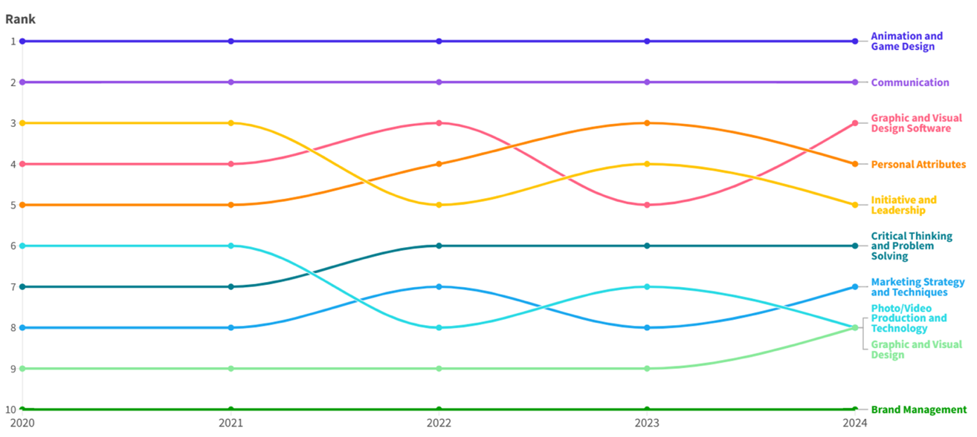
Source: The Fifth Sector/Unscrambled analysis of Lightcast job posting data (© Data City, 2025) for Greater Manchester, 2020-2024
Figure 6 Changes in demand for top 10 skills in Audio Production, 2020-2024
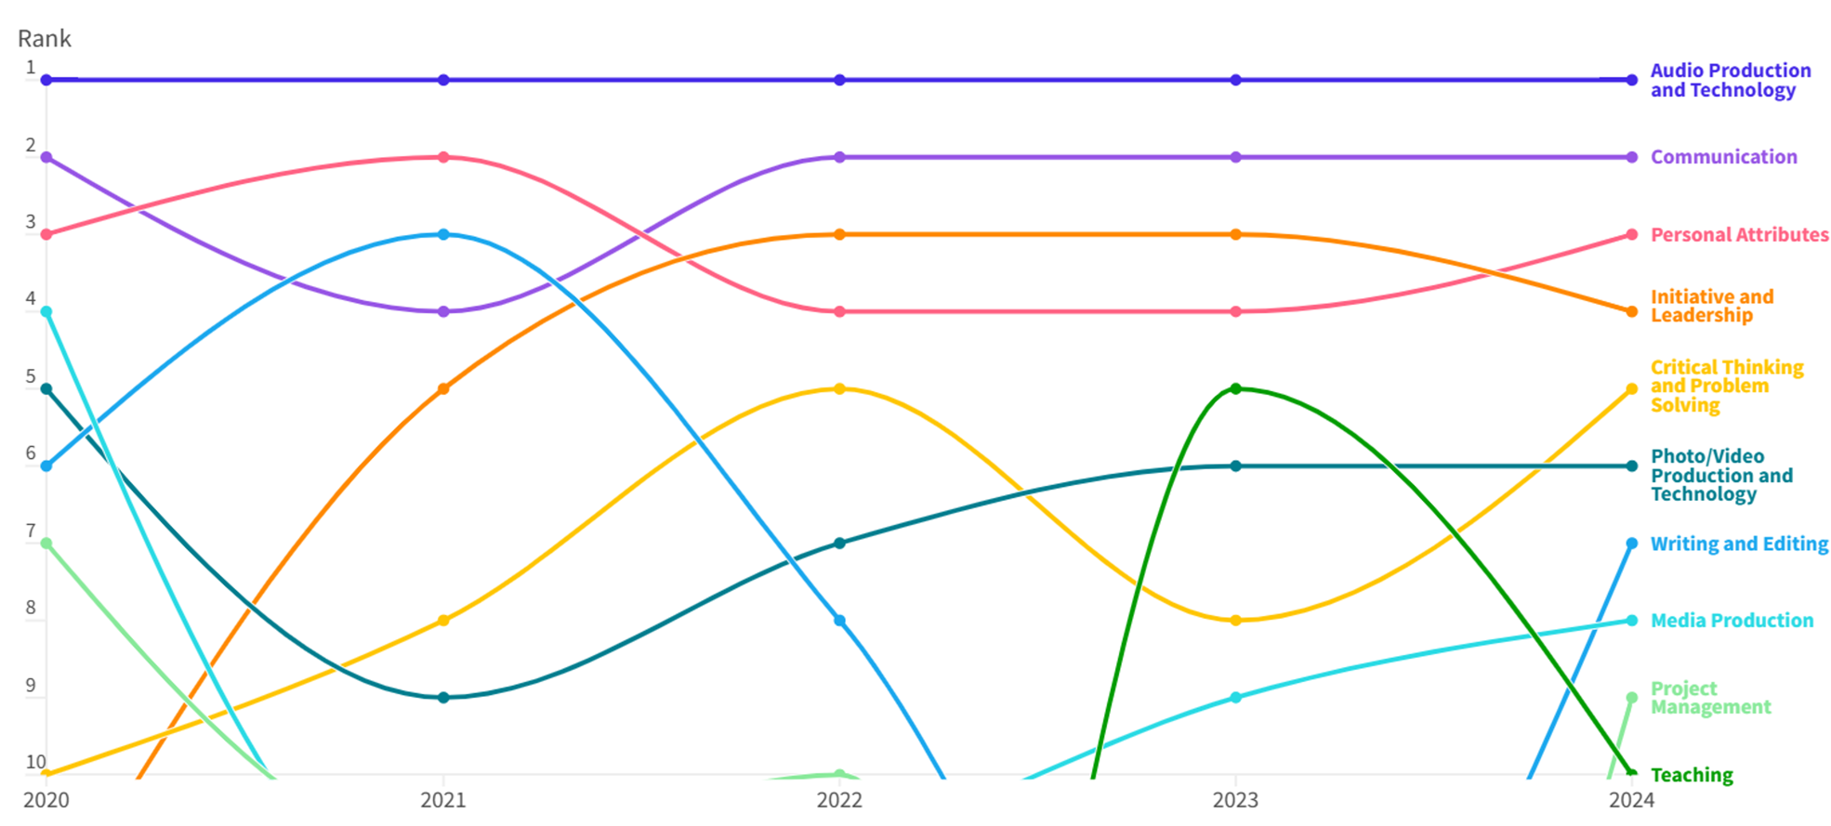
Source: The Fifth Sector/Unscrambled analysis of Lightcast job posting data (© Data City, 2025) for Greater Manchester, 2020-2024
Figure 7 Changes in demand for Top 10 immersive skills, 2020-2024
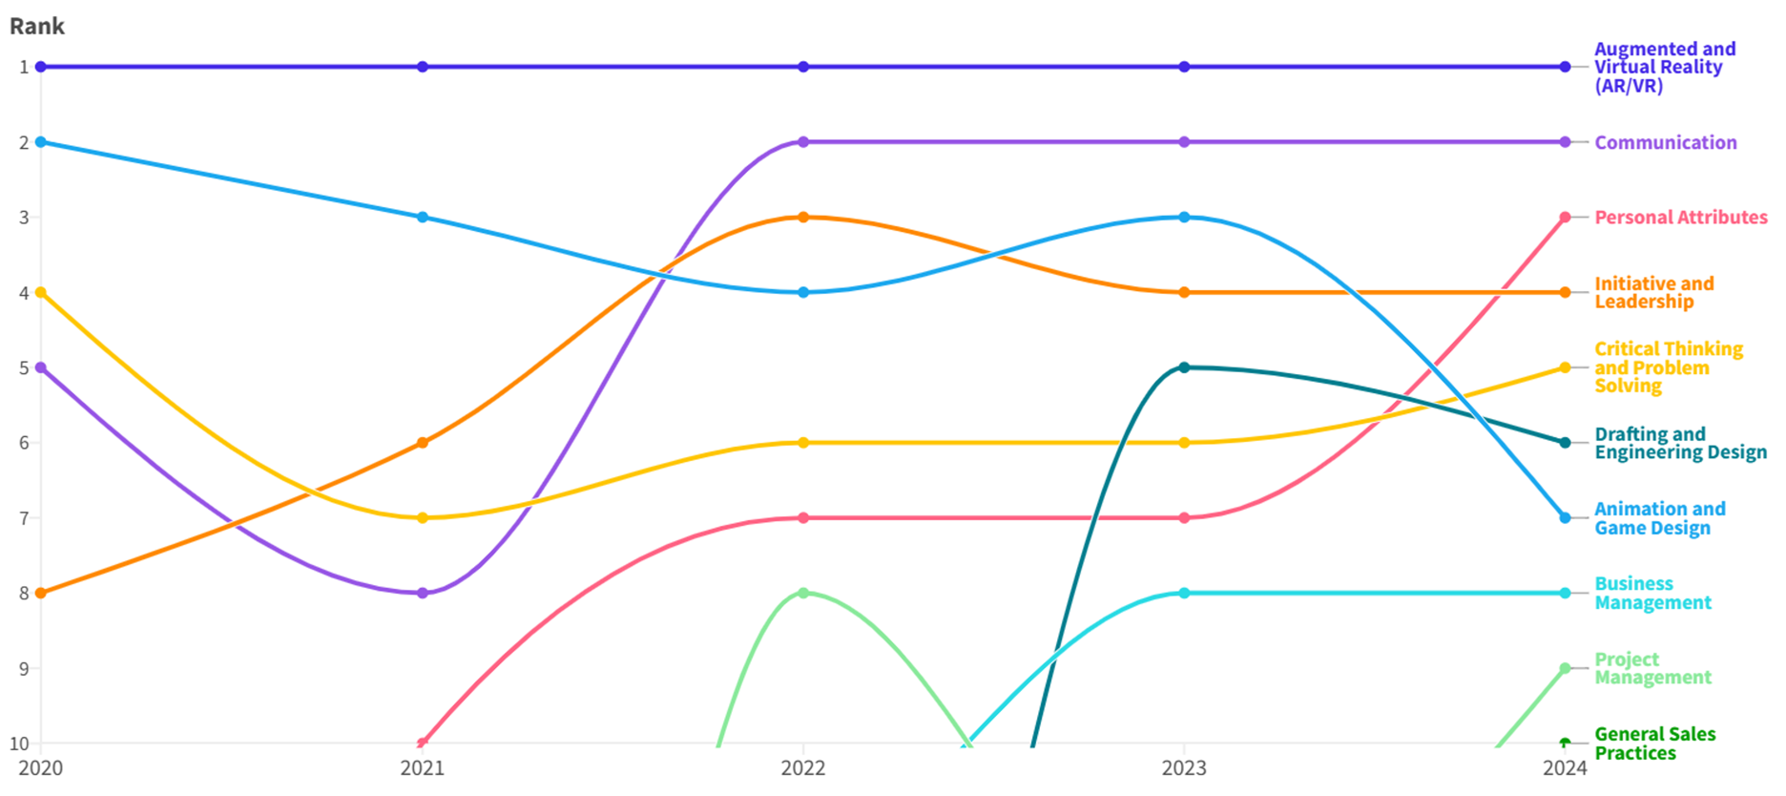
Source: The Fifth Sector/Unscrambled analysis of Lightcast job posting data (© Data City, 2025) for Greater Manchester, 2020-2024

4.4 R&D capacity
Innovation in creative technology is at the command of people, and it is people that make innovation work. This is often set in context of ‘storytelling’ – but, as the title of UKRI’s ‘Audience of the Future’ programme to support R&D in immersive content suggests, it is as much about changing attitudes and need in audiences as about technology. And linked to this understanding of the value chain – who is buying what and why.
The value of creative IP is related not only to the commercial exploitation of copyright material, but to investment in creative and technical production capacity. In this context, the small-scale grants awarded by MITIH – in particular, through the Dreamlabs – have arguably leant too heavily toward storytelling and have not given sufficient weight to understanding and growing the technological underpinnings of Createch. But we have not evaluated the economic impact of grants given to date.
Barriers to innovation start at relatively low values: Michelle Phillips of Royal Northern College of Music noted, ‘I've got one portable EEG cap. If I had two, you know, they're £17,000 each, we could do that in the concert hall.’ Companies face challenges accessing specialised equipment and expertise.
Procedural friction in grant applications adds to the cost of doing business, increases risk and may deter some firms from bidding altogether. One respondent reported that,
‘We put in a disproportionate amount of effort into writing various proposals... went through so many iterations and none of them [succeeded].’
This is borne out more widely in the wider innovation funding system. Analysis of Collaborative R&D grants for ‘AI and Data Economy’ made by UKRI to GM firms in the period 2019-24 show 26 awards to a total funding value of £2.01m and a total project value of £2.77m. This includes Audience of the Future, Immersive Technology Investment Accelerator and Create Growth competitions. Terms and conditions which exclude businesses within some ‘cultural’ SIC codes from applying further suppress levels of investment.
The report concerns itself with insights into key strengths and weaknesses in R&D capacity in GM’s Createch ecosystem. Detailed findings, including data and visualisations from LinkedIn, Lightcast, and other sources, form part of the analysis in sections 5 through 16 below.

4.5 Innovation flows: myth vs reality
Both desk research and consultation provide evidence of the gaps between assumptions made in innovation policy and the realities experienced by actors in the GM ecosystem including: how innovation moves within and between sectors; key relationships, networks, and collaborations; analysis of successful and unsuccessful R&D projects; and the correlation between movement of individuals with similar skillsets between actor and potential to develop collaborative innovation. Social network analysis (see Section 5, below) highlighted 30 organisations which are connected to a greater extent through employee movement - where one might expect to observe a greater network effect from any intervention.
Table 4 Policy Assumptions about Innovation Flows vs Evidence-Backed Reality
Policy Assumption | Evidence from research
"Digital skills are the future of work" | Digital development skills (e.g. JavaScript) are in decline; demand for hybrid production and coordination skills is rising
"Audio is a stable support sector with steady demand" | Audio shows flat or stagnant hiring, is network-isolated, and vulnerable to automation
“Creative sectors are inherently innovative” | Many creative organisations are operationally static or disconnected, needing collaboration infrastructure
"Universities are central innovation hubs" | Universities are in most cases passive connectors within networks and can often act as bottlenecks, not bridges, especially when funding excludes SME-led delivery
"Studio development needs are met by capital investment" | Technical craft is in demand but structurally underfunded and invisible in innovation strategy

Why these myths persist
- Funding frameworks prioritise outputs over ecosystems
- Legacy partnerships dominate decision-making
- Growth metrics are mistaken for health indicators
- 'Creative' is treated only as content, not capability infrastructure
These misconceptions lead to misplaced interventions, duplicated initiatives, and at-risk sectors being deprioritised.
"We've got all the infrastructure, but you haven't got a mechanism for actually joining up people, businesses and projects with funding to make anything happen."
Prof Mandy Parkinson, University of Salford

4.6 Suggested policy shifts
Devolution presents a further opportunity for Greater Manchester to take a lead in moving to an innovation-ready ecosystem:
Table 5 Moving to a Mesh-Enabled Policy for Creative Innovation
Area of Focus | Recommended Shift
Skills funding | Prioritise mesh-enabling skills: project ops, audio tech, cross-sector fluency
Infrastructure Investment | Include studio infrastructure and people in innovation readiness funding
R&D Strategy | Treat animation/audio as collaborative platforms, not output pipelines
University Engagement | Fund SMEs as leads, with universities as embedded support, not gatekeepers
Metrics & Evaluation | Measure activation and interconnection, not just growth or revenue

4.7 Reframing narrative for MITIH and beyond
Rather than position the creative sector as a high-growth engine or risk area, policy should recognise it as connective infrastructure:
- A layer that enables other sectors to communicate, train, and imagine
- A system of interoperable skills with wide strategic spillover
- A workforce adept at working across ambiguity, platforms, and disciplines
The need to view technology as an adaptive stack rather than fixed skills is supported both by practitioner experiences and by academic researchers:
"We've research time in our contracts. So, it's not really a case of paying the researchers because … I have one day a week, which is enough to do something, and others will have two days a week in different institutions around Greater Manchester. So, the time is there, if this is the research people want to be viewing."
Dr Michelle Phillips, Royal Northern College of Music

4.8 Policy alignment
Consultees point to a lack of strategic commitment to investment in key sectors, including film and television, and argue the case for more resource for Screen Manchester. Although Manchester is a partner to the Northern Skills Alliance for film and television, other regions, including Liverpool and West Yorkshire, have promoted Mayoral initiatives such as Beyond Brontes in Yorkshire, Liverpool City region’s Production Fund and training schemes promoted through the Film Office (Action! - Liverpool Film Office). As one interviewee with a national policy role asked,
‘Where is Andy Burnham in this?’
Conclusion
Our evidence provides counterpoints grounded in Greater Manchester's ecosystem data, clarifying where policy risks missing reality. The current discussion around further devolution of strategic accountability and funding for creative industries presents MITIH, GMCA, and national stakeholders with an opportunity to recalibrate funding, programme design and policy language to align with ecosystem realities.
Myths waste resources. Accurate framing supports resilience.

5. SOCIAL NETWORK ANALYSIS
To construct an accurate visual depiction of the connections between organisations in GM’s Createch ecosystem, the research has utilised a social network analysis (SNA) methodology to map workforce movement between 129 Greater Manchester companies, institutions and individuals.
SNA provides a method for displaying and analysing relational data through the mapping of ‘nodes’ (the individual actors within a network), connected by ‘edges’ (the ties that connect nodes to one another). Mapping connections in this way offers a means of quantitively capturing the overall structure of actors within a network. In this research context, the nodes are Createch organisations, and an edge is drawn between any two nodes if evidence is found of employee movement between them. The result is a “map” of inter-connected organisations, representing a visual eco-system (see Figure 8 for the graph and Table 6 for a further breakdown of its properties).
Organisations within the ecosystem were identified using a range of data sources including MITIH funding/project participant lists, Animation UK membership lists, evidence of previous UKRI-funded R&D activity and Manchester-focussed innovation event attendees. This identified a long list of 250+ entities, which was then analysed to identify potential linkages.
This analysis involved a four-step process:
- Checking the candidate business was legally active on Companies House
- Identification of the candidate’s ‘official’ profile on LinkedIn
- Using a mixture of LinkedIn tools, custom AI models and algorithms, the career and educational history of all current staff in the candidate organisation was then analysed to identify relationships with other organisations on the list. Further manual checks were then carried out to validate and ensure accuracy of the data.
- Construction of a matrix to enable the visual mapping of the relationships between organisations, institutions and individuals

Figure 8 Social network analysis graph of workforce movement through Greater Manchester Createch organisations

Table 6 Key objects and properties of the social network analysis graph
Graph Object and Property | Definition
Node | An identified organisation within the GM Createch ecosystem.
Edge (Or tie between nodes) | Evidence of employee movement between two organisations.
Node Radius (Size of node) | Determined by the total number of ties that a node has to all other nodes within the graph. Nodes with high levels of employee movement are larger.
Edge Weight (‘Thickness’ of ties connecting two nodes) | Determined by the number of employees moving between any two nodes. If there is evidence of large numbers of employees moving between two organisations, the edge connecting them is thicker.

Source: The Fifth Sector, March 2025

5.1. Benefits of social network analysis
Visually depicting the Createch ecosystem presents three primary opportunities for further insight:
- Identification of strong instances of connection between a group of organisations.
- Identification of missing, weak or potential connections between organisations.
- Stimulus for the development of strategies to reduce uncertainties and resource-waste, whilst encouraging judicious and active approaches to improving further collaboration and knowledge-sharing.
The first two opportunities act as prompts for further research. If a node is found to have strong connections to other nodes, it is prudent to consider the properties of the organisations represented. Factors such as the type of work completed, the company size and its connections to other nodes within the network should help Createch organisations build up their own index of potential collaborators. Whilst this signals areas of strength on which organisations should capitalise, it also leads us to interrogate the properties of poorly connected nodes to identify steps that could be taken to reinforce porous elements of the network structure.
The third opportunity refers to the fundamental principle on which the social network analysis portion of the research is based:
All organisations exist within a network of other organisations. Viewing yourself not as an individual, but as a member of an inter-connected network allows you to view your actions as they reverberate throughout the wider network structure and to allocate resources and broker relationships with greater strategic insight.

5.2 Limitations of SNA
Whilst the outcome of the SNA remains a useful proof of concept for the strengths of network visualisation, the nature of the data from which the network was derived limits the scope of analysis. The findings of this research must therefore be caveated by the following: workforce movement through the Createch ecosystem does not directly demonstrate innovation flow. The information provided is best understood as a starting point to gaining further information about interactions between network participants, which can be used to develop tangible and real-time pathways for innovation flow.

5.3. Overall network findings
The overall network (Figure 8) contains four outsized nodes: Manchester, Manchester Metropolitan and Salford Universities and the BBC. The large node radii of these organisations when compared to the rest of the graph demonstrates a high level of connection between these organisations and other network participants.
However: whilst there are high levels of workforce movement between the BBC and the three GM Universities (as depicted by the high edge weight, or increased line thickness), this is not replicated between the universities themselves. Dense clusters of nodes can be seen towards the centre of the graph, yet edge weight remains generally low, and nodes remain small.
Towards the peripheries of the graph, there is very little connection between nodes, most organisations in this area of the graph gaining access to the network through connection to a single other organisation (often a university).
The network can therefore be described as porous, with the BBC and the three main Manchester Universities acting as key pillars, holding the network together.
This lack of density can be quantified by counting the actual number of ties between nodes and dividing by the maximum number of possible ties within a network. Expressed as a percentage, with 100% being a completely inter-connected network, the GM Createch network as measured by workforce movement sits at a low 4.2%.

5.4. Community analysis
To aid visualisation and break-down the graph for further analysis, the network was separated into communities using a community detection algorithm. Given the way in which the GM Universities and BBC appeared to broker the relationship between large parts of the network, it made sense to run an algorithm that split the network structure into communities by sequentially removing edges with high ‘betweenness’. The result of this can be seen at Error! Not a valid bookmark self-reference. below.
Here, the network has been separated into 11 discrete, colour coded communities. Businesses and organisations can consult this colour-coded graph, as it identifies the nodes that connect their community to the network-at-large. For example, were it not for Cubic Motion’s connection to Realtime (top right), Scenegraph and Captive Devices would not be depicted within the network.
Figure 9 GM Createch social network graph, colour-coded according to community separation
Source: The Fifth Sector / Unscrambled, March 2025

Following this community separation, 11 subgraphs were created to identify the single community in which each organisation is situated. All subgraphs can be found in the network breakdown, but it is worth bringing four to attention here.
Addressing the community subgraphs in Figure 10 and Figure 11Figure 11, the network structure is visibly similar. Both “star shaped” clusters demonstrate a very low level of interconnection. Instead, the University in each cluster acts as the gravitational point to which all other nodes attach themselves, yet there is very little, if any, connection between the other nodes in the network. This raises the question: whilst Universities are clear focal points of workforce movement, can they really be seen, in this instance, to be facilitating the building of an eco-system, or do they exist as “workforce vacuums”?

Figure 10 Community subgraph 2
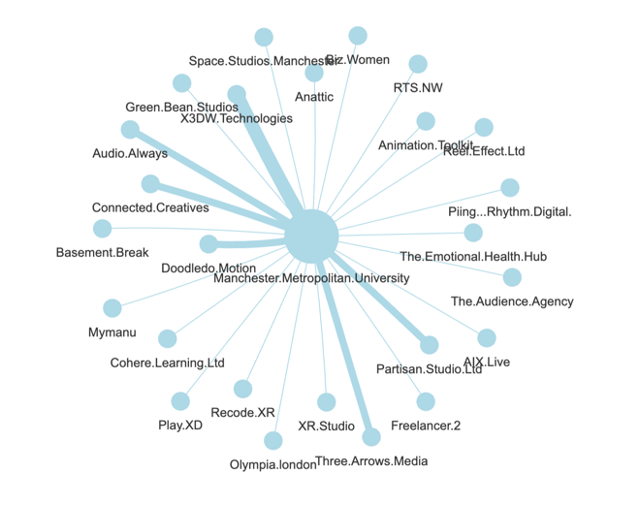
Figure 11 Community subgraph 4
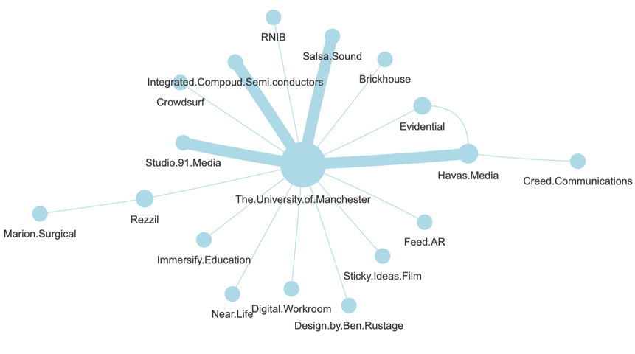
The BBC/University of Salford community (Community 1- Figure 12Figure 12) replicates this ‘star shape’ but contains a greater degree of interconnection – which speaks to the alignment of MediaCity and University of Salford.
Figure 12 Community subgraph 1
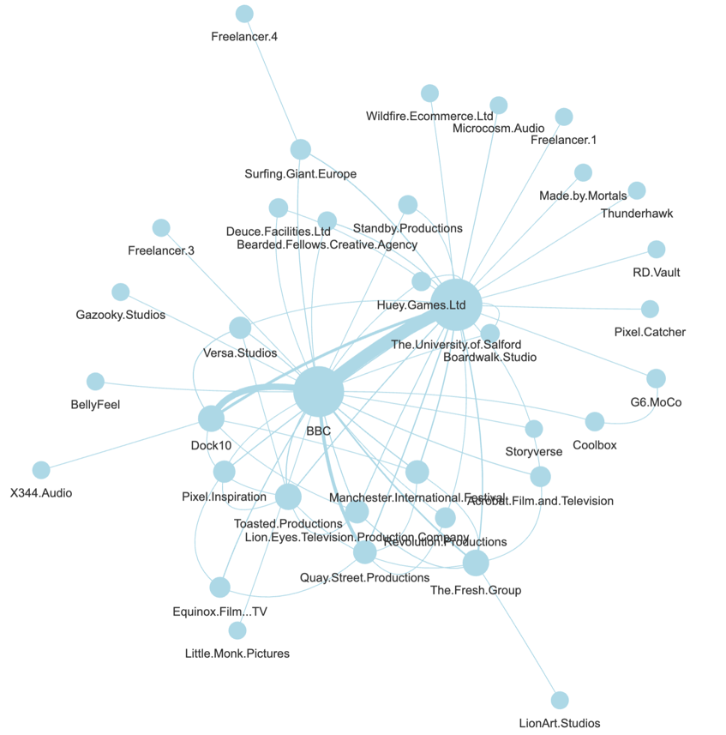
Communities 3 and 7 demonstrate a greater (though not overwhelming) level of inter-connectedness and density, moving closer to a conceivable interpretation of an ecosystem. This is most clearly demonstrated in the central cluster of Community 7.

Figure 13 Community subgraph 3

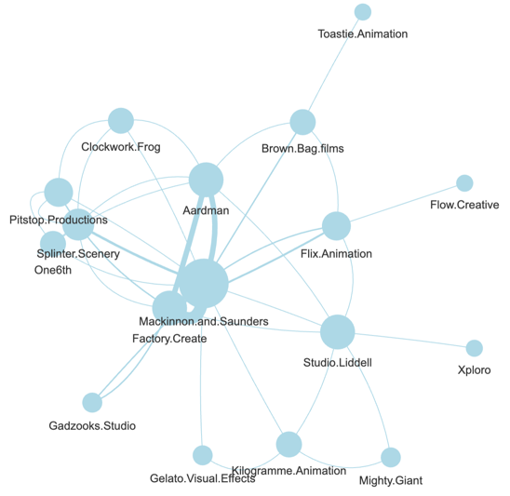
Figure 14 Community subgraph 7

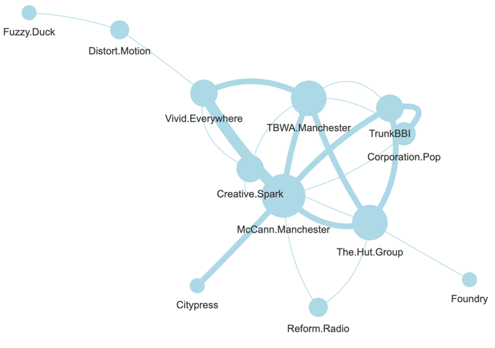
Community 8 points to the critical role of Realtime in convening relationships in companies across games, animation and virtual production.

Figure 15 Community subgraph 8
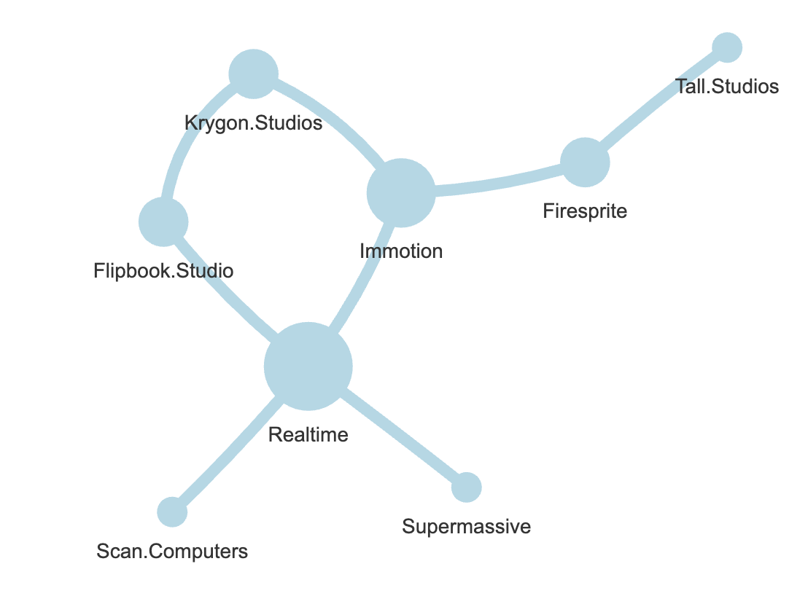

5.5 Network density
Expressed as a percentage, with 100% being a completely inter-connected network, the GM Createch network as measured by workforce movement sits at a low 4.2%.

Figure 16 Network density of communities with more than three nodes
Community  (four or more nodes | Total density/ interconnectedness (%)
Whole network | 4.2
Community 1 | 10.6
Community 2 | 7.6
Community 3 | 27.2
Community 4 | 11.7
Community 7 | 31.8
Community 8 | 28.5

5.6 Very small community memberships
The following are all distinct communities, entering at differing points in the network. These nodes should not be treated as related, s there is no connection between them. Owing to their very small size (triads and dyads), they have been grouped together for ease of reference.

Figure 17 Community subgraph 5
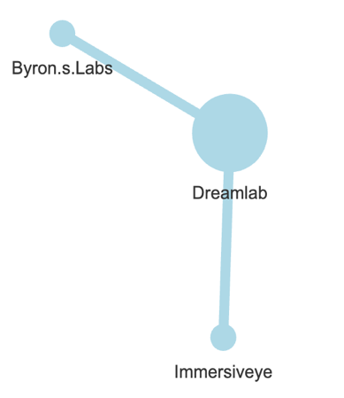

Figure 18 Community subgraph 6
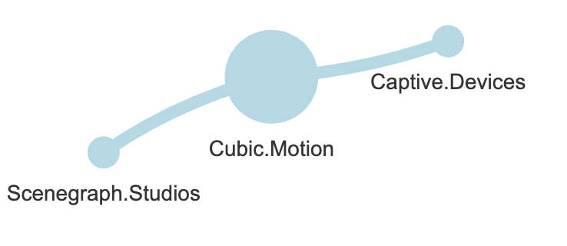
Figure 19 Community subgraph 9


Figure 20 Community subgraph 10
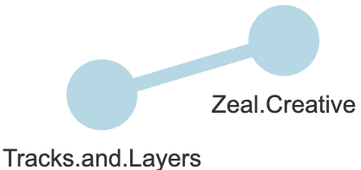
Figure 21 Community subgraph 11
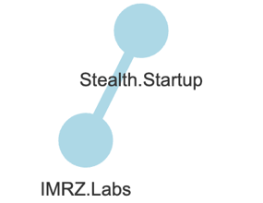

6. FUTURE-FACING SKILLS IN GREATER MANCHESTER’S CREATIVE-DIGITAL ECONOMY (2020–2024)
Overview
Analysis of Lightcast data on job postings from 2020 to 2024 across Greater Manchester’s creative and digital sectors reveals a complex picture of demand, resilience, and structural risk. By focusing on three subsectors—animation, audio production, and studio production—we gain insight into how regional capabilities align (or fail to align) with emerging opportunities and threats.
The Greater Manchester labour market data reveals a shifting skills landscape where traditional creative roles, emerging digital technologies, and hybrid capabilities are converging. By analysing five years of job postings across the creative and digital economy, we can see not only what employers are currently demanding, but how that demand is evolving—and where it points next.
This analysis draws on the top 100 specialised skills in job ads from 2020 to 2024, identifying key signals for curriculum development, cross-sector training, and network-level talent strategy. Key insights from this are:
- Transferable Skills Dominate
- Technical Fluency Matters,
- Software Literacy is Splintering
The data shows a clear hierarchy in employer demand:

6.1 Communication and agile thinking are ubiquitous
- Communication tops the list by a wide margin, with over 51,000 postings since 2020 and 7,887 in 2024—an 11% increase over five years.
- Agile Methodology, Project Management, and Initiative and Leadership are all in the top 10, despite coming from different professional domains.
These aren’t soft skills—they’re core operating behaviours in project-based, multi-stakeholder work environments. Employers are not just hiring specialists—they’re hiring collaborators.
6.2 Technical Foundation Still Counts
- JavaScript, Azure, AWS, and Python all feature prominently.
- Interestingly, many have declined in volume (e.g. JavaScript down 4,811 postings since 2020), suggesting saturation in traditional dev stacks and the growing influence of low-code/no-code tools.
- Universities should continue to teach core programming, but also emphasise tool adaptability, automation literacy, and API-based integration work.
6.3 Production skills now sit alongside cloud infrastructure
- Digital Content Creation, Video Production, and Media Production show sustained demand.
- These rank alongside Azure, Agile, and Data Analysis—underscoring how technical infrastructure and creative execution now co-exist in most project teams.

Table 7 Top 5 Digital sector skills by total demand (2020–2024)
Skill | Total Postings | 2024 Postings | Change (2020–24)
Communication | 51,419 | 7,887 | +1,167
Agile Methodology | 37,229 | 3,230 | -3,395
Management | 33,361 | 4,616 | -193
JavaScript (Programming) | 31,240 | 2,001 | - 4,811
Microsoft Azure | 28,594 | 2,936 | -1,313

Consultees expressed concerns about attracting and retaining higher level skills, both in production and research:

“In terms of developers I actually have seen, there were good developers that do game tech, and maybe even development and coding. But Manchester as an environment is really going to struggle with the academic research expertise.”

6.4 Implications for university partners
- Blend creativity with operational literacy
Embed agile project management, multidisciplinary teamwork, and client-facing communication across creative and technical courses. Graduates must be comfortable in hybrid teams, not just experts in narrow disciplines.
- Rethink ‘tech’ as an adaptive stack
Instead of doubling down on one coding language or platform, emphasise integration skills, low-code prototyping, and systems thinking. Students should leave able to collaborate with AI tools, not just compete with them.
- Centre studio and production craft as strategic
Production skills aren’t outdated; they’re quietly essential across sectors. Universities should elevate technical production disciplines (camera ops, video editors, motion designers) as collaborative agents in future media teams.
- Use Networked Learning Formats
The labour market shows demand for people who can move between contexts. Universities can reflect this by:
- Running cross-departmental projects
- Partnering with local SMEs for live briefs
- Placing students into federated hub projects as early-career collaborators
6.5 Strategic opportunity
Universities remain critical entry points into the ecosystem. But they can also become mesh enablers, supplying not just talent, but talent that is structurally aligned to how the creative and digital economy now works.
This requires moving beyond content mastery toward practice-based, ecosystem-aware training and building formal links to the federated hubs, immersive labs, and mesh infrastructure now emerging across Greater Manchester.

7. ECOSYSTEM RESILIENCE AND LABOUR MARKET DEMAND
As well as measuring demand for skills, Lightcast data helps correlate the extent to which workforce mobility between companies in the GM Createch ecosystem demonstrates connectivity between different actors within that ecosystem.

7.1 Animation: active but isolated
Animation continues to demonstrate strong labour market activity, with 6,093 unique job postings between 2020–2024, including 854 postings in 2024 alone. Demand encompasses both technical and creative leadership capabilities.
Table 8 Top Animation-related skills (GM 2020–2024)
Skill | Total Postings | 2024 Postings
Animation and Game Design | 6,093 | 854
Communication | 2,965 | 470
Graphic and Visual Design Software | 2,586 | 448
Initiative and Leadership | 2,557 | 400
Personal Attributes | 2,498 | 413

These figures confirm that the animation sector is multidimensional, with demand for both production and managerial skills. However, social network analysis (SNA) of inter-organisational connections shows that animation firms in GM are highly clustered within their own subgraphs.
The isolation of animation firms limits innovation potential and increases vulnerability to disruption - particularly from generative AI, which is already reducing demand for lower-tier production roles.

7.2 Audio: present, but drifting toward obsolescence
The picture for audio is more fragile. From 2020 to 2024, only 1,865 unique postings were recorded, with a flat 335 postings in 2024. The most in-demand skills are narrowly focused and do not show significant diversification.
Table 9 Top Audio-related skills (GM 2020–2024)
Skill | Total Postings | 2024 Postings
Audio Production and Technology | 1,865 | 335
Communication | 822 | 170
Personal Attributes | 680 | 146
Initiative and Leadership | 630 | 145
Problem Solving | 504 | 112
In network terms, audio firms are consistently peripheral; some are entirely disconnected or linked only via academic institutions. The sector is structurally under-integrated, and as AI increasingly encroaches on audio engineering, mastering, and even voice synthesis, there is no evident safety net or collaborative pathway for most firms.

7.3 Studio Production: a hidden mesh layer
Studio-related production roles (video, live media, post-production, lighting/sound) do not appear as distinct nodes in the ecosystem map, but labour market data shows they remain active, and may be underused assets in the wider network.
Table 10 Studio Production-related skills (GM 2020–2024)
Skill Subcategory | Total Postings | 2024 Postings
Photo/Video Production & Technology | 1,705 | 256
Media Production | 1,014 | 150
Production and Assembly | 381 | 55
Audio Production and Technology (cross-tag) | 280 | 38
Despite consistent demand, these skills are typically bundled into project-based or freelance roles rather than embedded in multi-sector workflows. This is a missed opportunity. Studio technicians are often the most mobile, cross-disciplinary workers in the creative economy. Their potential to serve as "network glue" -moving between animation, immersive, comms, and education - is currently untapped.

7.4 Synthesis: sector health vs network resilience
Each of the three focus sectors represents a very different network position, risk profile and strategic role in the ecosystem. Understanding the differences between the sectors is essential to developing a strategy to help them collaborate more effectively.
Table 11 Sector health vs network resilience
Sector | Network Position | Job Market | Risk Level | Strategic Role
Animation | Clustered, inward | Strong | Medium | Needs bridging
Audio | Isolated, marginal | Weak | High | Needs reattachment
Studio Production | Invisible, underutilised | Stable | Medium | Should act as cross-sector mesh

7.5 Strategic recommendations
- Support Animation as a connector
Fund collaborative microgrants that position animation firms as creative leads on cross-sector projects (e.g. XR for health, interactive learning platforms, branded content for local industry).
- Reintegrate Audio into growth domains
Target immersive, wellness, and live digital experiences as strategic footholds for audio skills. Use relay placements and matchmaking to make these pathways explicit.
- Elevate Studio Production as infrastructure
Establish production crew residencies and technical fellowships embedded across sectors. These roles should be designed not just to produce outputs, but to facilitate collaboration and transfer between disciplines.
By triangulating labour market demand with structural network analysis, this canvas provides a sharper understanding of where Manchester’s creative economy is strong, where it is at risk, and where overlooked capabilities might be repurposed to build a more resilient, interconnected future.

8. CURRICULUM-TO-COLLABORATION: ALIGNING TALENT PIPELINES WITH ECOSYSTEM NEED

Purpose
Clearer understanding of the evidence of demand will help university and training providers align curricula, placements, and industry engagement strategies with the real structural needs of Greater Manchester’s evolving animation, audio, and studio production ecosystem.
Interactions with students and businesses need to move beyond generic ‘digital skills’ rhetoric. Institutions need to use concrete job data and network positioning to develop curricula and specific interventions through CPD that prepare students and employers not just for employment, but for ecosystem participation.

8.1 Labour market signals: what employers are asking for
The most in-demand creative/digital skills in Greater Manchester from 2020–2024 highlight a need for hybrid fluency, not just technical depth.
Regions including GM are making increasing use of digital skills “bootcamps” – these are becoming more adaptable but are very tech orientated . The model itself – short, sharp training – is suitable for graduate development but is it really addressing the Createch need?
Table 12 Selected high-demand cross-sector skills (2020–2024)
Skill | Total Postings | 2024 Postings | Trend (Δ 2020–24)
Communication | 51,419 | 7,887 | +1,167
Agile Methodology | 37,229 | 3,230 | −3,395
Digital Content Creation | 16,853 | 1,844 | −2,021
Project Management | 16,348 | 1,879 | −1,609
Video Production | 14,295 | 1,488 | −1,192

Interpretation
Communication and project-based workflow fluency are non-negotiable.
Traditional ‘content creation’ demand is fragmenting across platforms; studio production skills are increasingly embedded, not named.
Programming skills (e.g. JavaScript) are declining as AI tooling rises; but integration and adaptability are rising in value.

8.2 Sector readiness for collaboration
SNA and job data show that animation and audio firms are structurally under-connected, while studio production roles often go unacknowledged as network enablers.
Table 13 Sector readiness for collaboration
Sector | Network Role | Labour Demand | Curriculum Gaps
Animation | Clustered | High | Weak in cross-sector application
Audio | Peripheral | Low | Needs immersive + adaptive focus
Studio Production | Hidden infrastructure | Stable | Framed too narrowly as support

8.3 Curriculum recalibration recommendations
Animation
Gap: Over-specialisation in pipelines (e.g. pre-vis, rigging) without enough exposure to product, storytelling or impact design.
Action
- Co-design cross-disciplinary briefs with digital health, edtech, or immersive partners.
- Offer ‘Creative Director in Context’ modules: students lead small cross-sector teams (with audio, dev, comms).
- Integrate project management tools (e.g. Notion, Trello, Agile frameworks) into production courses.
Audio
Gap: Curriculum still anchored to traditional production or commercial music environments.
Action
- Partner with immersive labs, cultural venues, wellness start-ups and public realm agencies.
- Launch ‘Sonic Environment’ projects where students prototype sound design for physical/virtual space.
- Add modules on AI-assisted sound design, spatial audio, and real-time sound in interactive systems.
Studio Production
Gap: Framed as a linear technical skillset, not as an active connector or collaborator.
Action
- Reframe Studio Production as ‘innovation delivery roles’ - project leads, technical producers, system integrators.
- Embed students into multi-sector project sprints (with two or more partners) via federated hubs.
- Formalise Production technician-in-residence roles co-mentored by industry and university.

8.4 From teaching to participation: structural suggestions
Table 14 From teaching to participation: structural suggestions
Opportunity type | Implementation ideas
Live industry briefs | Partner with federated hubs to run real-time design sprints
Floating residencies | Assign students as rotating collaborators in SMEs/labs
Skills observatory | Use job/SNA data to inform annual curriculum reviews
Creative mesh minors | New tracks that combine studio craft + systems fluency

"I think an interesting piece of work would be to explore what the sector would like in terms of skills development. Manchester has in the last year been awarded the UNESCO designation of City of Life and Learning, and University of Manchester and Manchester Met are working in collaboration with the city to deliver that as part of a three-year project that's just started. Part of that work is developing a skills framework for Manchester."
Prof Jillian Griffiths, Director of SODA, Manchester Metropolitan University

8.5 Strategic rationale
Universities in GM are central nodes in the creative economy by location and history, not by design. The current risk is that their courses supply graduates into disconnected pipelines, feeding the fragmentation observed in creative sectors, not solving it.
By retooling their role - from knowledge providers to ecosystem co-builders - universities can:
- Address emerging skill gaps early
- Retain and embed more graduates locally
- Plug education directly into collaboration infrastructure

8.6. Summary
Universities and training providers need support to evolve from discipline-first curriculum design to mesh-aware talent development.
Rather than asking, ‘How do we get more students into animation/audio/studio jobs?’, the better question is:
‘How do we train students to participate in collaborative systems where creative skills are the connective tissue - not just the output?’

9. HIDDEN INFRASTRUCTURE: SURFACING THE UNDER-RECOGNISED ASSETS IN ANIMATION, AUDIO AND STUDIO PRODUCTION
Our research has revealed the overlooked people, practices, and places that enable creative and digital collaboration in Greater Manchester - particularly in animation, audio, and studio production - but are routinely left out of strategy documents, funding priorities, and innovation policy.
By surfacing this latent infrastructure, we build a case for investing in what already work, rather than continually funding new interventions atop an ignored foundation.

9.1 What do we mean by hidden infrastructure?
Hidden infrastructure refers to the operational, relational, and cultural assets that:
- Don’t appear in organisational charts or procurement frameworks
- Often aren’t eligible for strategic funding
- Are essential for continuity, delivery, and ecosystem fluidity
These are the editors, the freelancers, the session runners, the fixers, the crew, the connectors, and the trusted venues - and their absence from strategic investment is a silent failure.

9.2 Roles in demand but strategically ignored
Table 15 Roles in demand but strategically ignored
Role Type | 2020–2024 Postings | Notes
Video Production & Tech | 1,705 | Stable demand across sectors, especially immersive
Media Production | 1,014 | Embedded in events, content, broadcast, education
Production Assembly | 381 | Often freelance, bridging multiple disciplines
Audio Production | 280 | Technically specialised, rarely included in R&D funding

These roles never appear in innovation funding calls, yet are necessary for delivering almost any cross-sector project.

9.3 Network roles missing from strategy
Social network analysis showed that:
- Audio and studio firms sit on the edge or are completely absent
- Production roles are present in every working system but never show up as nodes
- Their work happens between organisations, making them structurally invisible in centralised models
Table 16 Risks of continued neglect
Risk | Result
Underfunded continuity | Projects stall when hidden infrastructure burns out or leaves
Innovation theatre | Without doers, innovation remains conceptual
Centralisation of success | Only well-funded or visible organisations get to deliver collaborative work
Talent drain | Freelancers and crew move to London or exit the sector entirely

9.4 The strategic value of hidden infrastructure
Rather than treating this group as a cost line, they can be:
- Network glue: able to move between projects, sectors, and skill domains
- Delivery accelerators: bringing real-world logistics and production experience
- Trust brokers: freelancers are often the connective tissue between disconnected organisations
- Cultural continuity holders: carrying the norms, pace, and humour that keep collaboration human

9.5 Intervention ideas: how to support it properly
A. Hidden infrastructure fund
- Microgrants to cover the cost of production enablers, not just creative leads
- Pay for technicians, fixers, local crew, editors, and production PMs
B. Visibility programmes
- Tag these roles explicitly in all network diagrams and reports
- Ask every public-funded project: ‘Who’s delivering this under the radar?’
C. Trusted crew registry
- Fund and maintain a trusted local roster of technical freelancers and operators
- Used by federated hubs to matchmake delivery talent with innovation needs
D. Infrastructure residency scheme
- Place technicians and producers in residence at hubs - not to create, but to enable

9.6 Reframing value: from shadow workers to strategic assets
Table 17 Reframing value of hidden infrastructure
Current framing | Proposed reframing
‘Back-office support’ | Network enablers
‘Cost centres’ | Cross-sector activators
‘Freelancers’ | Fluid infrastructure
‘Technicians’ | Collaborative engineers

This isn’t just semantics—it determines who gets funded, retained, and respected.

9.7 Recommendation summary
Table 18 Recommendation summary for hidden infrastructure
Audience | Action
Funders | Include infrastructure roles in project eligibility criteria
Hubs | Budget for embedded delivery roles—not just leadership or R&D
Universities | Create technician-in-residence roles across departments
SMEs | Access pooled production talent through a regional mesh platform

The creative economy doesn’t run on vision alone—it runs on the people who keep the shoots moving, the audio clear, the edit tight, and the room running. This hidden infrastructure isn’t an optional add-on. It’s the system.
If we ignore it, we’ll keep funding ‘projects’ with no delivery. If we support it, we make innovation possible at scale, and with integrity.

10. RESILIENCE READINESS CANVAS: ANIMATION, AUDIO & STUDIO PRODUCTION
This canvas is designed to guide funding prioritisation, policy attention, skills development, and hub-level intervention. It assesses how prepared each of the three core sectors is to withstand and adapt to structural change – particularly automation – and how to remedy the effects of consistent underfunding and disconnection from wider innovation ecosystems.

10.1 Sector overview
Table 19 Resilience readiness - sector overview
Sector | Current Function | Visibility in Ecosystem | Strategic Position
Animation | IP development, motion content | Clustered, not cross-cutting | High-potential creative driver
Audio | Sound design, post, music | Isolated, under-networked | Under-leveraged, easily disrupted
Studio Production | Technical craft and facilitation | Invisible but everywhere | Critical infrastructure layer

10.2 Labour market signals
Table 20 Sector market signals, based on job postings (2020–2024) across GM:
Sector | Total Job Postings | 2024 Postings | Skill Breadth | Role Variety | Trendline
Animation | 6,093 | 854 | Broad (creative and managerial) | Diverse | Decline from 2022
Audio | 1,865 | 335 | Narrow | Shrinking | Flatlining
Studio Production | ~3,400 (all types) | ~500 combined | Functional and transferable | Moderately broad | Steady

Interpretation
- Animation still hires, but largely internally within clusters
- Audio shows structural demand collapse
- Studio craft continues across sectors, but goes unrecognised

10.3 Risks of exposure to automation
Table 21 Risks of exposure to automation
Sector | Exposure Risk Level | Vulnerable Tasks | Survivable Roles
Animation | High | In-betweening, visual ideation, rigging | Direction, storytelling, lead design
Audio | High | Mixing, mastering, ambient scoring | Sound design for XR/live, spatial work
Studio Production | Medium | Post clean-up, scheduling, basic edits | Live ops, rapid prototyping, hybrid crews

Interpretation
- Animation and audio both face direct automation threats at junior/mid-level.
- Studio skills are more resilient but need reframing as cross-sector enablers.

10.4 Social Network Analysis insights
Social network analysis data matches labour patterns observed in job postings: audio is at the edge, animation is central but siloed, and studio roles are embedded but not strategically mapped.
Table 22 Social Network Analysis Insights
Sector | SNA Position | Connectivity Pattern | Risk Resulting from Network Status
Animation | Moderately central | Inward cluster, few bridges | Innovation bottleneck
Audio | Peripheral | Dyads, disconnected edges | Structural fragility
Studio Production | Non-visible | Embedded in workflows | Strategic invisibility

10.5 Sector-level risk ratings
Table 23 Sector-level risk ratings
Factor | Animation | Audio | Studio Production
Job Demand | ✅ | ⚠️ | ✅
Adaptability to AI | ⚠️ | ❌ | ✅
Network Resilience | ⚠️ | ❌ | ⚠️
Cross-sector Potential | ✅ | ⚠️ | ✅
Visibility to Funders | ✅ | ❌ | ❌

10.6 Recommendations by sector
Animation
Animation is a bridge-building priority: the sector must be drawn into immersive, healthtech, edtech, and marketing networks.
Tactical Interventions
- Microgrants that force non-creative collaborations
- Paid relay roles for animation creatives to work with public sector briefs
- Early-stage IP acceleration with cross-discipline teams
Audio
Audio is a structural rescue priority: the sector is bleeding relevance; action must be swift and focused.
Tactical Interventions
- Fellowship and residency schemes placing audio designers in XR, wellbeing, and virtual environments
- Mesh credits to reward other orgs for bringing audio into collaborative projects
- Immersive sound lab co-hosted with a digital or animation node
Studio Production
Studio production is an activation priority: it is already present in all parts of the ecosystem, but not strategically deployed.
Tactical Interventions
- Embed production techs as horizontally mobile collaborators
- Technical residency schemes in each federated hub
- Reframe studio roles in curricula as ‘cross-sector translators’

10.7 Strategic Framing
This analysis supports a shift from sector support to network activation. It shows that the real vulnerability isn’t a lack of skills, but the lack of intentional structures to connect and repurpose them as technologies and economies shift.
Each sector contributes, but none survive alone.

11. MESH ENABLER ROLES: REFRAMING STUDIO PRODUCTION AS NETWORK INFRASTRUCTURE
The evidence points to the need to reposition studio production roles - from camera ops to editors to technical producers - as connective agents within the wider innovation mesh. This canvas argues for their strategic elevation, outlines their cross-sector value, and proposes targeted interventions to deploy them as collaborative catalysts in federated hubs.

11.1 Studio Production: the infrastructure hiding in plain sight
Despite being largely absent from policy documents and funding models, studio production roles remain in steady demand across all sectors of the creative economy. They underpin broadcast, digital content, immersive experiences, advertising, and hybrid events, yet remain structurally invisible in innovation planning.
"It creates your own social capital, which is the point basically. It's just thinking about it completely in a different way isn't it?"
Together, these account for over 3,000 job postings in the last five years, with over 499 in 2024 alone. This is not a declining skillset—it is a critical layer of applied technical capability that operates between sectors.
Table 24 Studio Production skills demand in GM (2020–2024)
Skill Subcategory | Total Postings | 2024 Postings
Photo/Video Production & Technology | 1,705 | 256
Media Production | 1,014 | 150
Production and Assembly | 381 | 55
Audio Production and Technology | 280 | 38

11.2 Why Studio Production roles are natural mesh enablers
Studio professionals possess three characteristics that position them uniquely as network activators:
- Mobility – the ability to move easily between projects, clients and formats
- Translational ability – converting creative intent into deliverable, distributable formats
- Cross-disciplinary fluency – collaborating with designers, developers, marketers and engineers.

11.3 Examples of key mesh enabler roles
To activate this value, we propose formalising and embedding the following roles across the federated innovation hubs:

Table 25 Examples of key mesh enabler roles

Role Title | Primary Function | Target Sectors | Value to Mesh
Technician-in-Residence | Embedded AV/content lead in collaborative projects | All hubs | Provides continuity + tool fluency across sectors
Floating Producer | Cross-project PM and delivery broker | Animation / Audio | Reduces fragmentation, increases delivery velocity
Workflow Generalist | Connects disparate software/tools into coherent process | Studio / Digital teams | Prevents technical debt, speeds up prototypes
Live Hybrid Ops Lead | Designs and delivers hybrid event, stream, or showcase | Public / Cultural | Translates R&D into visible outputs
These roles often exist in the gaps between formal organisations - hired as freelancers or suppliers - but they are the people who keep multidisciplinary projects moving.

These are not job titles to be hired—they are roles to be assigned within lab projects, residencies, or microgrant schemes.

11.4 Where these roles could sit
A. In federated hubs
Each hub should have 1-2 mesh enabler posts that:
- Rotate between projects
- Support at least two sectors
- Are trained and tracked as collaboration infrastructure, not cost centres
B. Within existing anchor organisations (e.g. dock10, HOST, SODA)
Mesh enabler roles could act as:
- Internal-external translators for SMEs using facilities
- Brokers between animation/audio firms and production workflows
- Coordinators for immersive testbeds or live XR productions

11.5 ROI: what the network gains
Table 26 Outcomes enabled by mesh enabler roles
Outcome | Enabled by Mesh Role
Increased cross-sector collaboration | Through shared technical language and delivery support
Faster and more complete prototyping | By embedding production capacity within exploratory projects
Higher visibility of network activity | Via well-produced showcases, demos, and documentation
Lower dropout in microgrant projects | With mesh roles smoothing logistics, tech and team handovers

11.6 Strategic recommendations
For funders and policymakers
Fund mesh enabler placements as part of all lab, ‘sandbox’ or microgrant projects.
Recognise technical production as strategic creative infrastructure in skills and innovation policy.
Shift studio production funding from ‘back-office ops’ to cross-sector activation.
For hubs and studios
Assign clear mesh roles for production technicians with visible network responsibilities
Include studio professionals in planning, not just delivery
Use these roles to document, narrate, and translate collaboration across the mesh
For universities
Reframe studio production courses as interdisciplinary innovation training.
Add minor tracks in technical mediation, live content strategy, and systems fluency.

11.7 Conclusion
Studio production is often treated as a support service. But the evidence shows it is active, stable, and structurally under-leveraged. Reimagining studio production roles as critical components of the innovation mesh - not behind the scenes, but embedded at the centre of collaboration, translation, and delivery – could transform the understanding, take up and effectiveness of measures to promote innovation and commercialisation of IP.

12. ZEBRA ORGANISATIONS
The research demonstrates the need to move away from unrealistic expectations of ‘high growth’ typically associated with innovation funding, and to identify and elevate a class of organisations within the creative economy – in this case, in animation, audio, and studio production - that prioritise sustainable, ethical, and community-aligned practice over speculative and extractive models. These ‘zebra organisations’ are often undervalued by funders but are critical to mesh stability and long-term ecosystem health.

12.1 What Are Zebra organisations?
Zebra organisations are:
- Profitable but principled: They aim for sustainability, not dominance.
- Collaborative by design: They build and share resources rather than compete for market share.
- Slow-growing and values-led: They often resist scale-for-scale's-sake logic.
- Often overlooked: Traditional funding models prioritise innovation, speed, and IP extraction.
These organisations are frequently invisible in strategy documents because they don’t self-promote, don’t scale rapidly, and aren’t positioned as ‘leaders’ in traditional terms.

12.2 Zebra traits
Data and network analysis identify some key Zebra traits:
Table 27 Traits which Identify Zebra organisations
Indicator | What to Look For in GM Data
Hiring volume (low/moderate) | Not high churn; stable teams
SNA centrality (bridging, not dominant) | Connects nodes, doesn’t dominate graph
Job diversity | Multi-skilled, cross-sector collaboration
Sectoral overlap | Works across creative, education, health, etc.
These organisations may not post their achievements often but show up in multiple networks, play behind-the-scenes roles, and facilitate cross-sector delivery.

12.3 Why Zebra organisations matter to GM's creative ecosystem
The interviews reveal examples of organisations functioning as trust brokers, cultural memory holders, skills anchors and providing invisible infrastructure to the network::
“The infrastructure we've built through the Bridge AI project really clicks into all the other labs. So, we have the same capabilities now and the same operational expertise, probably a little bit ahead, to be honest, in some of the labs, because we've done some hands-on motion capture, hybrids, multi-cam, all mixed up, and we've gotten really quite good at it now. I think the big opportunity … is that we're attractive satellite partner for any of these things, be it a remote thing or a scale up”
Florian Block, dock10 / University of York
Darren Grice of Salford City Council describes the role of cultural organisations and clusters as trust brokers in the Salford ecosystem:
“We've got three quite different clusters in the city. I'm working with ecologies of those to try to build on-the-ground leadership and connection and visioning between each of those. But the next bit is about how they then start to interface with each other as mini-cultural districts that then collectively start to make a story for the city.’
Table 28 Role of Zebra organisations in GM creative ecosystem
Role in Ecosystem | Example Impact
Trust Broker | Connects freelancers and orgs across sectors
Cultural Memory Holder | Maintains informal practices, unwritten rules
Skills Anchor | Trains and retains talent long after grants run out
Invisible Infrastructure | Provides space, mentorship, or kit on a "borrow, don't bill" model

Without these organisations, the mesh may become brittle—a system full of projects but lacking continuity or culture.

12.4 Why Zebra organisations struggle to attract support
Zebra organisations within the creative economy are sometimes miscategorised as ‘lifestyle’ businesses:
- Don't fit scale-driven KPIs
- Too operational to count as innovation
- Too community-facing to be commercial
- Often excluded from VC/investor ecosystems
This leads to chronic underfunding, exhaustion, and attrition—despite playing a vital ecosystem role.

12.5 Interventions to support Zebra organisations
Both the data and interviews identify specific needs for Zebra organisations:
A. Zebra organisation fund
Kate O’Connor of Animation UK highlighted the need for different timing of funding that could address the specific nature of development pipelines for animation companies:
"There’s no support available when animations are at development, conception state. Unlike film and TV, where you just need a script and a producer, … for animation, there's a lot of time and money and innovation needed at the very conceptual stage when you're talking about storyline and characters and technique and marrying that to different markets and business models."
B. Mesh Priority Partners
Flexible and standardised legal and procurement arrangements are needed to facilitate stable long term return on investment in partner projects:
“For small things, we can't go through a legal review on a per case basis. So, we need a clearly formulated collaboration agreement template and a permissive IP agreement... for short projects, there needs to be staff and resources available that you can't really hire for short things, like highly skilled people, unreal techs, AI researchers.” – Studio Production lead
C. Peer recognition mechanisms
Richard Wormwell of dock10 described the need for longer-term development relationships:
“To bring one of those [freelance specialists] in for a 12-month contract and pay them a decent salary and get value out of them delivering short-term projects is just not viable. [There needs to be] some kind of pool of talent that you can draw on more widely. There's a regional struggle getting people for short-term contracts like this.”
D. Cultural Infrastructure Track
“I think [partnerships] could also look at the place specifically and also bring into that conversation: how does the place activate, what's the offer when you come to visit Media City, which has a visitor economy mechanism to it as well, - but they should reinforce the identity of place, and it should reinforce the creative industry side of them."
– Darren Grice, Salford City Council
Table 29 Interventions to Support Zebra Organisations
Intervention Type | Description
Zebra Organisation Fund | Multi-year operational support for values-led SME collaborators
Mesh Priority Partner | Automatic partner eligibility in mesh projects
Peer Recognition Mechanism | Let hubs nominate 2 orgs/year as foundational collaborators
Cultural Infrastructure Track | Include zebras in infrastructure funding, not just capital projects
Conclusion
Zebra organisations are not flashy. They are resilient, trusted, and radically practical. If mesh infrastructure is to endure, it needs these organisations to be not just visible, but funded, respected, and embedded in strategic planning.

13. COLLABORATION FRICTION: UNDERSTANDING WHAT’S GETTING IN THE WAY
In order to implement any changes or recommendations, we first need to unpack the behavioural, structural, and operational frictions that prevent animation, audio, and studio production firms in Greater Manchester from collaborating, either with each other, with universities, or with digital sector peers.
This canvas draws directly from social network analysis, skills demand data, and labour trends to show that the barriers to collaboration are not about willingness, but about infrastructure gaps, capability mismatches, and systemic design flaws.

13.1. The collaboration gap is structural, not personal
From qualitative consultation and network mapping, a consistent message emerges: most organisations want to collaborate but can’t afford to waste time on short-term project funding, ill-matched partnerships, incompatible processes, or funding bureaucracy. The system has no collaborative muscle memory, so attempts default to either:
- One-off commissions
- Overly formalised partnerships with universities
- Reliance on legacy players (e.g. BBC, anchor institutions)
Social Network Analysis (SNA) confirms the extent of the disconnect. Most firms are not embedded in a living network. Instead , they’re either reliant on a single partner or operating in a silo.

Table 30 Indications of the collaboration gap
Indicator | Insight
Low network density | Only 4.2% of possible org-to-org links are active
Weak connections between audio & animation sectors | Few bridges between the two sectors
Hub-and-spoke dominance | BBC and universities act as central, but passive nodes
Invisible studio roles in SNA | Infrastructure providers not represented as collaborators

13.2 Job market shows friction in coordination & communication
While creative and technical skills dominate many job postings, project management, communication, and collaborative tools are also in high demand. This signals that coordination itself is a skill gap - not just content production.
Table 31 Cross-sector collaboration enabler skills (2020–2024)
Skill | Total Postings | 2024 Postings | Trend (Δ 2020–24)
Communication | 51,419 | 7,887 | +1,167
Project Management | 16,348 | 1,879 | −1,609
Agile Methodology | 37,229 | 3,230 | −3,395
Problem Solving | 15,643 | 2,266 | +1,074
Initiative and Leadership | 23,663 | 3,140 | +1,275

There is demand for coordination roles, but they are not embedded in the creative curriculum or supported in small companies.
Many organisations simply don’t have a project-level layer that knows how to initiate, scope, or sustain collaborative delivery.

13.3 Sources of friction

The evidence suggests five key types of collaboration friction:

Table 32 Five types of collaboration friction

Type of friction | Description | Evidence source
Structural | Organisational models don’t support experimentation or shared ownership | SNA mapping demonstrates fragmentation and isolation within and between sectors  Participant and stakeholder feedback on current structures
Operational | No shared platforms, rhythms, or language across disciplines | Job data shows low uptake of agile processes and shared project tools
Resource-Based | Firms don’t have spare staff or resource to ‘explore’ R&D without guaranteed ROI | SME interviews, absence of coordination roles
Relational | No recent experience of successful collaboration | Legacy failure of top-down programmes (e.g. HOST)
Procedural | Funding/reporting too complex or slow | Funder consultation, failed pilots

13.4 Strategic recommendations
A. Fund coordination roles, not just delivery
- Introduce “Collaboration Producers” funded by microgrants to support cross-org engagement
- These are not admin roles—they are responsible for translation, mediation, and shared output planning
B. Default to pre-funded models
- Make exploration frictionless by offering pre-paid collaboration credit
- Light-touch criteria: must involve at least one partner from another sector (e.g. animation + audio)

C. Standardise formats and language
- Provide shared frameworks for:
  - Workflows (e.g. use of Notion, Miro, Trello)
  - Shared brief templates
  - Glossaries of sector-specific terms (to reduce lost-in-translation moments)
D. Make trust visible
- Fund demos, open retrospectives, and story-based reporting rather than PDF outputs
- Visualise successful collaborations in the network graph and storytelling artefacts

13.5 Conclusion: friction is a design problem, not a cultural one
The lack of collaboration stems from neither a lack of interest nor concerns about competition: it’s about missing infrastructure, unfunded roles, and systems built for solo delivery, not shared making.
By identifying and removing collaboration friction, federated hubs can finally unlock the mesh potential of Greater Manchester’s creative economy, allowing animation, audio, and studio production firms to not just survive, but to interoperate.

14. CATCH BEFORE COLLAPSE
The Catch Before Collapse canvas identifies which parts of Greater Manchester’s creative ecosystem -specifically in Audio, Animation, and Studio Production -are at risk of disappearing unless intervention is fast, targeted, and frictionless.
This isn’t a panic narrative; it’s a clear-headed triage map based on trends evidenced in the data. The goal: act now to preserve critical capabilities before they quietly disappear.

14.1 Framing the risk
Collapse in this context doesn’t mean dramatic closures or sector-wide implosions. Instead, it often looks like:
- Experienced freelancers leaving the region or sector
- Key firms becoming dormant or shrinking into silence
- Skills becoming redundant due to automation or lack of investment
- Cultural and economic contributions going unrecognised by funders or policymakers
The challenge is not that these sectors have no value, but that their value is difficult to measure in traditional economic terms and thus often overlooked in strategic planning.
Job posting trends across 2020–2024 offer early indicators of where market relevance is declining or stagnating: Audio shows stagnation; traditional digital skill areas are in decline. Studio roles are steady but structurally under-leveraged. These signals show not just market shifts, but indicate where skills risk being lost without targeted support.
Table 33 Labour market warning signs
Sector/Role | Total (2020–2024) | 2024 Postings | Trend
Audio Production & Tech | 1,865 | 335 | +35
Digital Content Creation | 16,853 | 1,844 | -2,021
JavaScript (proxy for dev stack) | 31,240 | 2,001 | -4,811
Video Production & Tech | 1,705 | 256 | Steady

14.2 Network isolation
Social network analysis reinforces the labour market story. Disconnected organisations and under-networked sectors have fewer opportunities to collaborate, learn, or be visible to funders.
Table 34 Network Isolation
Sector | Network centrality | Cross-sector bridges | Collapse risk
Animation | Mid-tier | Few | Medium
Audio | Low | None or one | High
Studio Production | Absent | Embedded, not visible | Medium-High
Audio firms are mostly isolated. Studio infrastructure exists but is largely uncoordinated. Animation has some density but very few cross-sector linkages. These configurations reduce resilience.

14.3 Collapse Conditions
Based on ecosystem indicators, several risk factors are active simultaneously:
Table 35 Collapse Conditions
Risk factor | Present in GM ecosystem
Declining hiring | Yes (Audio, wider Digital Skills)
Organisational isolation | Yes (Audio, Studio Production)
No obvious funders | Yes (All three sectors)
Cultural invisibility | Yes (Audio, Studio)
Fragmented infrastructure | Yes (All sectors)
These compound over time, leading to quiet erosion. Once capabilities vanish, rebuilding them is costly and slow.

14.4. Immediate interventions
- Microgrant lifeline projects: Provide small-scale, fast-access grants to at-risk firms. Prioritise cross-sector prototypes, shared outputs, or community-facing demos. The goal is not scale, but continuity.
- Creative recovery residencies: Place audio professionals and studio technicians into structured placements within immersive, health, or learning projects. Provide funding, visibility, and new collaborative experiences.
- Mesh monitoring: Use real-time SNA overlays, job data, and participation tracking to spot when organisations or roles begin to slip out of view. Create triggers for re-engagement and outreach.

14.5 Reframing opportunity
The following repositions at-risk sectors not as problems to be fixed, but as assets to be renewed in context:
Table 36 Reframing Opportunity
Sector | Collapse risk | Reframe opportunity
Audio | High | Reintegrate as immersive sound specialists
Animation | Medium | Shift to narrative innovation infrastructure
Studio | Medium-High | Elevate production craft to system-enabling layer
This is not about nostalgia for a regional broadcast production ecosystem which has been eroded by centralisation of commissioning in London and competition from overseas streamers. It’s about retooling sectors to remain relevant to how digital, cultural, and commercial work now happens.

14.6 Strategic recommendations
Timely, visible, and collaborative intervention is needed to preserve at-risk capabilities in GM's creative economy. Prompt action will avoid expensive reinvention. More importantly, these steps would build resilience amongst existing cultural and creative sectors while enabling them to adapt into relevance, rather than being written off as obsolete.
Table 37 Strategic recommendations to mitigate risk of ecosystem collapse
Who | Action
Funders | Launch "Catch Before Collapse" strand under SPF or mesh innovation funds
Hubs | Use SNA + hiring data to identify and re-engage at-risk actors
Universities | Offer pivot placements and technical bursaries
Policymakers | Integrate sector risk into creative and innovation strategy planning
These moves require a recalibration of policy positions based on current models of public sector investment in innovation and assumptions of continuing growth in creative industries; but the immediate investments required are small compared to the cost of regenerating lost capability later.

15. NETWORK ACTIVATION LADDER
The Network Activation Ladder offers a framework for assessing how ready an organisation is to participate meaningfully in collaborative, cross-sector innovation, particularly within animation, audio, and studio production in Greater Manchester.
This ladder enables funders, hub managers, and policymakers to move beyond measures which mimic sector labels applied at national level three decades ago, and instead evaluate organisations based on their network behaviours, hiring patterns, skill diversity, and collaborative capacity.

15.1 Framing the Challenge
Many creative organisations are misclassified, not just in SIC-based sector definitions, but more importantly in innovation systems. Some are large but inert. Others are small but highly connected. Mapping should seek to establish not, ‘Are they in animation?’ but, ‘Can they work well across boundaries, with others, under uncertainty?’
The Activation Ladder provides a structured way to answer those and similar questions.

15.2 Ladder levels
Network activation is a scale, like Technology Readiness Levels; the higher the level, the better prepared the organisation is to act as an effective part of the creative ecosystem.
Table 38 Levels at the Network Activation Ladder
Level | Label | Behavioural indicators | Network position | Typical needs
0 | Disconnected | No active projects, no known partnerships | Absent from SNA | Reintroduction, light-touch engagement
1 | Isolated Specialist | High internal activity, no external collaboration | Peripheral node | Visibility, entry points, light incentives
2 | Passive Connector | Subcontracted or linked to only oe organisation, but not initiating collaborations | Single tie, no bridge role | Support to lead, confidence building
3 | Active Collaborator | Leads or shares projects with others, across at least two sectors | Mid-tier, multiple weak ties | Resources to scale, convening support
4 | Mesh Operator | Routinely brokers, connects, shares across diverse projects | Central node, bridging role | Core funding, infrastructure investment

15.3 Mapping to GM Creative Ecosystem
Table 39 Mapping the Network Activation Ladder to the GM creative ecosystem
Sector | Typical Level | Activation Issues
Animation | 2–3 | Over-clustered; needs bridges outside creative sector
Audio | 0–1 | Isolated, few active collaborations
Studio Production | 1–2 | Present but structurally invisible; rarely leads collaborative work
These levels reflect network analysis and job pattern data, not just anecdote.

15.4 Strategic use cases
Funder application assessment
Use the ladder to identify whether a project leader has real network potential or needs partnership support.
Hub outreach planning
Prioritise ladder levels 1 and 2 for proactive engagement and onboarding into mesh projects.
Evaluation and progress tracking
Monitor movement up the ladder across years and investment rounds—track activation, not just output.

15.5. Suggested interventions by ladder level
Table 40 Suggested Interventions by Network Innovation Ladder level
Level | Recommended intervention
0 | Invitation to discovery workshops, visible map inclusion
1 | Targeted microgrant with required external partner
2 | Collaborative design funding, shared delivery scaffold
3 | Flexible scaling fund, peer convening, evaluation support
4 | Multi-year funding, system-building roles, onboarding support for others

The Network Activation Ladder would help de-risk collaboration by offering a shared language for understanding organisational readiness. It shifts strategy from managing sectors to enabling systems; supporting creative organisations not just to grow, but to connect, contribute, and lead.

16. IMMERSIVE AS INTEGRATION: USING XR TO RECONNECT ANIMATION, AUDIO, AND STUDIO CRAFT
There’s a tendency to treat VR/XR as a speculative or emerging activity. MITIH (correctly) positions immersive technologies - VR and XR - not as a standalone sector, but as a practical integration layer. Immersive work connects animation, audio, and studio production in ways that are already in motion but structurally unsupported. Our findings reinforce the case for immersive production as a delivery surface for mesh logic—a domain where disconnected capabilities can be recombined and reactivated.

16.1 Immersive is not the future—it’s the available middle
. But in Greater Manchester, immersive is already:
- Used in marketing, healthtech, training, and digital heritage
- Delivered through hybrid teams: animators, audio designers, camera crews, Unity developers
- Supported by existing facilities like dock10, Realtime’s Virtual Production studio and several universities
Our focus sectors are engaging with immersive:
- Animation is already contributing to immersive teams—especially in design and interaction.
- Audio is under-utilised, despite the importance of soundscapes in immersion.
- Production roles are implicit—there’s no immersive without studio crew, AV, and delivery logistics

16.2 Demand signals from the data
Immersive roles are present (modest but growing) and draw skills directly from animation and audio.
Table 41 Selected VR/XR-adjacent skills (2020–2024)
Skill | Total postings | 2024 postings
AR/VR Development | 1,138 | 159
Animation and Game Design | 410 | 35
Communication | 386 | 55
Problem Solving | 379 | 52
Audio Production & Technology | <100 (est.) | Low but present

16.3 Why immersive works as integration
The gap isn’t in technology—it’s in coordinated participation by disconnected creative sectors.
Immersive production requires hybrid collaboration by default. A typical immersive project might involve:
Table 42 Elements of Immersive Projects
Role | Sector | Contribution
3D Animator | Animation | Visual assets and spatial storytelling
Sound Designer | Audio | Sonic texture, ambience, feedback
Camera/AV Ops | Studio Production | Capture, spatial layout, pipeline setup
Creative Technologist | Digital | Integration of code, interaction, logic
Producer/Coordinator | All | Project architecture and delivery
There’s no immersive project that doesn’t bridge sectors. That presents the opportunity to build better mesh networks.

16.4 What needs fixing
A. Funding is still siloed
- Immersive work is often forced into arts or tech categories—not both.
- Animation firms can’t access immersive pots because they’re classified as ‘content’
- Audio rarely gets invited to the table
B. No shared workflows or prototyping spaces
- Tools are fragmented: some use unreal, others unity, others off-the-shelf platforms
- No shared sandbox or lab model for creative/digital crossover at scale
C. XR feels like a risk, not a bridge
- For many small firms, XR is expensive, over-hyped, or inaccessible
- Immersive needs to be repositioned as a place to collaborate, not a tech bet

16.5 Tactical interventions
Immersive co-lab model
- Create 3-month pilot labs where animation, audio, and studio teams are embedded in immersive test projects.
- Offer funding, facilities (dock10, HEIs), and project scaffolding.
- Outputs: playable prototype, public demo, shared IP.
Technical production fellowships
- Fund cross-sector studio roles (e.g. producer, tech lead, editor) to be permanently mobile between XR projects.
- These fellows become connective tissue, not project owners.
Reclassify XR as multi-sector
- Work with funders (e.g. Innovate UK, ACE, AHRC) to define immersive as a convergent (and converging) space, not a vertical sector.
- Ensure animation/audio firms can access immersive funding without changing business models.

16.6 Reframing Immersive: From hype to mesh surface
Table 43 Reframing XR as a mesh surface
Old view | New view
‘VR is the future’ | XR is where sectors already overlap
‘Immersive = hardware’ | Immersive = hybrid collaboration
‘You need specialists’ | You need connectors + co-creation
‘It’s a niche | It’s the only place most sectors meet
7. Repositioning MITIH for the future
Table 44 Repositioning MITIH for the Future
Audience | Action
Funders | Back immersive as a bridge, not a tech bet
Hubs | Use immersive work as onboarding into the mesh
Studios | Frame XR not as service, but shared production ground
Universities | Create cross-department immersive teams (animation + audio + tech)

16.7. Conclusion
Immersive production isn’t a distraction from efforts to grow core sectors of the creative economy: it’s the glue that could hold them together. It demands the collaboration Greater Manchester needs more of.
By treating immersive not as ‘the future,’ but as the space where disconnected capabilities reconnect, GM partners can unlock a real-world, fundable, cross-sector model for creative resilience.
Realising a GM-wide strategic partnership around mesh capabilities and immersive production methods would help overcome the ‘path dependency’ on a regional broadcast production ecosystem which can no longer be sustained. Accompanied by appropriate funding models and practical support (CPD), it would also provide a spur to the region’s vibrant cultural organisations and freelance producers of original IP, and signal the scale of GM’s ambition to external investors.

17. POLICY PLAYBOOK
This playbook translates the MITIH Createch Ecosystem Report into an investment and delivery framework. It observes two overarching principles that should apply to policy and investment:
- Fund the infrastructure, not just the outputs.
- Back the connectors, not just the stars.

17.1 Strategic objective
Support Greater Manchester’s creative-digital sectors (specifically Animation, Audio, and Studio Production) not as isolated content generators, but as vital connective infrastructure. These capabilities underpin immersive delivery, ecosystem resilience, and innovation across sectors including health, education, and manufacturing.

17.2 Action Areas (Aligned to Report Sections 7–14)
Table 45 Policy Playbook - action areas
Area | Recommended intervention /  (Report section #) | Lead organisation | Cost range | Expected outcome | Time to impact
Mesh capability | Fund mesh enabler roles (e.g. technical producers, project operators, production integrators) embedded in federated hubs (Section 11.3) | GMCA + MITIH | £10k–£50k per role | Cross-sector delivery acceleration and skills transfer | 3–6 months
Animation activation | Microgrants that position animation studios as creative leads on XR/health/edtech pilots (Section 10.6) | MITIH | £20k–£50k per round | Bridge animation into strategic growth domains | 3–9 months
Audio reattachment | Immersive sound fellowships and relay placements in non-arts sectors (Section 10.6) | MITIH + Uni of Salford | £30k–£60k each | Reintegrate isolated audio capabilities | 6–12 months
Studio production recognition | Technician-in-Residence and Mesh Fellowships embedded in innovation hubs and universities (Sections 9.5, 11.3) | GMCA + Universities | £15k–£45k per placement | Elevate delivery roles as strategic assets | 6–12 months
Skills realignment | Support for curriculum co-design: 'Creative Mesh Minors', agile modules, live briefs (Sections 6.4, 8.3) | Uni of Salford, SODA | £20k–£80k per department | Align talent pipeline to mesh fluency demands | 12–18 months
Network activation | Develop a ‘Trusted Crew Registry’ to surface hidden infrastructure and support project matchmaking (Section 9.5) | MITIH + Industry Partners | £25k setup + operations | Improve project continuity and reduce collaboration friction | 3–6 months
R&D system reform | SME-led innovation pilots with universities as embedded partners, not gatekeepers (Section 4.5) | Innovate UK + MITIH | £50k–£100k per pilot | Increase innovation participation from under-networked sectors | 6–12 months
Immersive as integration | Treat immersive not as the ‘future’ but the ‘available middle’—fund cross-sector integration labs (Section 16.3) | MITIH | £50k–£150k | Position immersive as connective layer across disciplines | 6–12 months

17.3 Policy Shifts Required (see Section 4.6)
- From Output to Infrastructure: Fund the roles and rhythms that make innovation executable, not just the shiny artefacts.
- From Gatekeeping to Enablement: Shift universities from central gatekeepers to mesh-aware delivery partners.
- From Growth Rhetoric to Resilience Metrics: Track workforce mobility, project interoperability, and network density.
- From Digital Hype to Human-Centric Skills: Invest in agile, communicative, and integration-oriented capabilities.
- From Legacy Metrics to Ecosystem Intelligence: Use SNA, job data, and live briefs to track real system dynamics.

17.4 Implementation Priorities (2025–2026)
- MITIH to act as an operational testbed for mesh-based innovation funding: microgrants, labs, and placement schemes.
- GMCA to pilot mesh enabler residencies and cross-sector crew registries across key federated hubs.
- Funders (UKRI, Innovate UK, AHRC) to ringfence funding for audio, studio, and animation as connective infrastructure.
- Universities to adopt mesh fluency frameworks in curriculum reform, using job market and SNA evidence to redesign participation pathways.

ACKNOWLEDGEMENTS
The report draws heavily on original data sources and new methods of analysis. I acknowledge the contributions and insights of Jon Bains of Obsolete.com, Andy Goodwin of Unscrambled, Lynne McCadden and Jacob Simmons in the origination and synthesis of the evidence and conclusions.
Copyright in the Lightcast jobs data and business data used in compiling sector business estimates belongs to Data City (www.thedatacity.com) and its licensors, © Data City 2025.
I would also like to thank the businesses, investors and stakeholders who gave generously of their time to substantiate our findings with their own experience and expertise. These include:
Anthony Hatton of Salford City Council, who commissioned this research and contributed invaluable intelligence and connections
Ayla Suveren, Creative Industries Consultant
David Norris, AIX Live
Kate O’Connor, founder and Executive Chair, Animation UK
Richard Wormwell and Florian Block, dock10
Jonny Freeman, Director, CoSTAR Foresight Lab
Carl Jones, Maccon Jones (ex-Cloud Imperium)
Dr Steve Henderson, Director, Manchester Animation Festival
Dave Moutrey and Sarah Elderkin, Manchester City Council
Prof Jill Griffiths and Paul Bason, Manchester Metropolitan University
Dr Michelle Phillips, Royal Northern College of Music
Darren Grice of Salford City Council
Prof Mandy Parkinson, University of Salford
Dan Wallman, TechNative Digital
Caroline White, Pete Woodbridge and Roger McKinley, all of whom delivered and continue to deliver elements of the MITIH project

Iain Bennett, The Fifth Sector, March 2025.

APPENDICES

APPENDIX 1: METHODOLOGY
The report employed a range of research methods and data sources, including:
- Desk based research: diverse data sources including
- ONS data (BRES/IDBR) on population, scale and distribution of Creative Industries businesses and employment
- Proprietary data obtained from Data City (www.thedatacity.com, © Data City 2025) used to correlate and add to ONS findings and inform further analysis of Createch supply chains
- Analysis of Lightcast data (© Data City 2025) on job postings to provide insight to changes in the demand for digital and creative skills in the period 2020-2024, with LinkedIn used to provide further evidence for Social Network Analysis of connections between businesses, research institutions and freelancers in the GM Createch ecosystem
- Analysis of data on other R&D investments in Digital & Creative Industries in GM made by UKRI over the period 2020-2024
- Reference to academic and ‘grey’ literature (industry reports) to support findings and conclusions
- Stakeholder engagement activities (interviews, consultations) with GM and national contributors

APPENDIX 2: UKRI AWARDS TO GM FIRMS FOR ‘AI AND DIGITAL’ COLLABORATIVE R&D, 2019-2024
Table 46 Summary of UKRI awards to GM Firms for Collaborative R&D in creative projects within AI & Digital calls, 2019-2024
Competition theme | Number of Awards | Total Award Offered (£) | Total Project Costs
Audience of the Future | 6 | 759,287 | 1,260,739
Production Innovation for Immersive Content | 1 | 223,989 | 223,989
Immersive Technology Investment Accelerator | 3 | 582,583 | 832,262
DCMS Create Growth Fund | 16 | 440,808 | 454,913
Total | 26 | 2,006,667 | 2,771,903

APPENDIX 3: SOCIAL NETWORK ANALYSIS
This list of companies was constructed through analysis of company names supplied by MITIH, analysed via LinkedIn to identify movements of employees between them,
Table 47 All Companies Mapped by Social Network Analysis (n = 129)
3DW Technologies | Dreamlab | Mackinnon and Saunders | Scenegraph Studios
Aardman | Equinox Film & TV | Made by Mortals | Space Studios Manchester
Acrobat Film and Television | Evidential | Manchester International Festival | Splinter Scenery
AIX Live | Factory Create | Manchester Metropolitan University | Standby Productions
Anattic | Feed AR | Marion Surgical | Stealth Startup
Animation Toolkit | Firesprite | McCann Manchester | Sticky Ideas Film
Audio Always | Flipbook Studio | Microcosm Audio | Storyverse
Basement Break | Flix Animation | Mighty Giant | Studio 91 Media
BBC | Flow Creative | Mymanu | Studio Liddell
Bearded Fellows Creative Agency | Foundry | Near Life | Supermassive
BellyFeel | Freelancer 1 | Olympia London | Surfing Giant Europe
Biz Women | Freelancer 2 | One6th | Tall Studios
Boardwalk Studio | Freelancer 3 | Partisan Studio Ltd | TBWA/Manchester
Brickhouse | Freelancer 4 | Piing (Rhythm Digital) | The Audience Agency
Brown Bag films | Fuzzy Duck | Pitstop Productions | The Emotional Health Hub
Byron's Labs | G6 MoCo | Pixel Catcher | The Fresh Group
Captive Devices | Gadzooks Studio | Pixel Inspiration | The Hut Group
Citypress | Gazooky Studios | Pixipixel | The University of Manchester
Clockwork Frog | Gelato Visual Effects | Play XD | The University of Salford
Cohere Learning Ltd | Green Bean Studios | Prompting Plus | Three Arrows Media
Connected Creatives | Havas Media | Quay Street Productions | Thunderhawk
Coolbox | Huey Games Ltd | RD Vault | Toasted Productions
Corporation Pop | Immersify Education | Realtime | Toastie Animation
Creative Spark | Immersiveye | Recode XR | Tracks and Layers
Creed Communications | Immotion | Reel Effect Ltd | TrunkBBI
Crowdsurf | IMRZ Labs | Reform Radio | Versa Studios
Cubic Motion | Integrated Compound Semi-conductors | Revolution Productions | Vivid Everywhere
Design by Ben Rustage | Kilogramme Animation | Rezzil | Wildfire Ecommerce Ltd
Deuce Facilities Ltd | Krygon Studios | RNIB | Xploro
Digital Workroom | Lion Eyes Television Production Company | RTS NW | XR Studio
Distort Motion | LionArt Studios | Salsa Sound | Zeal Creative
dock10

Table 48 Social Network Analysis: Community Subgraph 1 (n = 36)
Acrobat Film and Television | G6 Moco | RD Vault
BBC | Gazooky Studios | Revolution Productions
Bearded Fellows Creative Agency | Huey Games Ltd | Standby Productions
BellyFeel | Lion Art Studios | Storyverse
Boardwalk Studio | Lion Eyes Television Company | Surfing Giant Europe
Coolbox | Little Monk Pictures | The Fresh Group
Deuce Facilities Ltd | Made by Mortals | The University of Salford
dock 10 | Manchester International Festival | Thunderhawk
Equinox Film and TV | Microcosm Audio | Toasted Productions
Freelancer 1 | Pixel Catcher | Versa Studios
Freelancer 3 | Pixel Inspiration | Wildfire Ecommerce Ltd
Freelancer 4 | Quay Street Productions | X344 Audio

Table 49 Social Network Analysis: Subgraph 2 (n=26)
AIX Live | Olympia London
Anattic | Partisan Studio Ltd
Animation Toolkit | Piing Rhythm Digital
Audio Always | Play XD
Basement Break | Recode XR
Biz Women | Reel Effect Ltd
Cohere Learning Ltd | RTS NW
Connected Creatives | Space Studios Manchester
Doodledo Motion | The Audience Agency
Freelancer 2 | The Emotional Health Hub
Green Bean Studios | Three Arrows Media
Manchester Metropolitan University | X3DW Technologies
Mymanu | XR Studio

Table 50: Social Network Analysis: Subgraph 3 (n = 17)
Aardman | Mackinnon and Saunders
Brown Bag Films | Mighty Giant
Clockwork Frog | One6th
Factory Create | Pitstop Productions
Flix Animation | Splinter Scenery
Flow Creative | Studio Lidell
Gadzooks Studio | Toastie Animation
Gelato Visual Effects | Xploro
Kilogramme Animation

Table 51 Social Network Analysis: Subgraph 4 (n = 18)
Brickhouse | Feed AR | Rezzil
Creed Communications | Havas Media | RNIB
Crowdsurf | Immersify Education | Salsa Sound
Design by Ben Rustage | Integrated Compound Semiconductors | Sticky Ideas Film
Digital Workroom | Marion Surgical | Studio 91 Media
Evidential | Near Life | The University of Manchester

Table 52 Social Network Analysis: Subgraph 5 (n = 3)
Byron S Labs
Dream Lab
Immersive Eye

Table 53 Social Network Analysis: Subgraph 6 (n = 3)
Captive Devices
Scenegraph Studios
Cubic Motion

Table 54 Social Network Analysis: Subgraph 7 (n -12)
Citypress | Foundry | TBWA Manchester
Corporation Pop | Fuzzy Duck | The Hut Group
Creative Spark | Mcann Manchester | Trunk BBI
Distort Motion | Reform Radio | Vivid Everywhere

Table 55 Social Network Analysis: Subgraph 8 (n = 8)
Firesprite | Realtime
Flipbook Studio | Scan Computers
Immotion | Supermassive
Krygon Studios | Tall Studios

Table 56 Social Network Analysis: Subgraph 9 (n = 2)
Prompting Plus
Pixipixel

Table 57 Social Network Analysis: Subgraph 10 (n = 2)
Tracks and Layers
Zeal Creative

Table 58 Social Network Analysis: Subgraph 11 (n – 2)
Stealth Startup
IMRZ Labs

References
Manchester City Council (2024). Creative Industries in Manchester (unpublished)
Oktra (2025). The Cost of Office Space in Manchester 2025 Report
Realtime (2025). LinkedIn post announcing its Virtual Production department, https://www.linkedin.com/posts/realtime-studio_virtualproduction-unrealengine-activity-7250129118292324353-8HeW?utm_source=share&utm_medium=member_desktop&rcm=ACoAAAAPzsUBDFXF4NzOPdllZyr9uuxdek8JKSM
Tether, B. (2022) Creative Clusters and Sparse Spaces: Manchester’s Creative Industries and the Geographies of Deprivation and Prosperity. Creative Industries Policy & Evidence Centre, London.
The Fifth Sector (2020). SODA CPD Market Demand Study for Manchester Metropolitan University (unpublished)

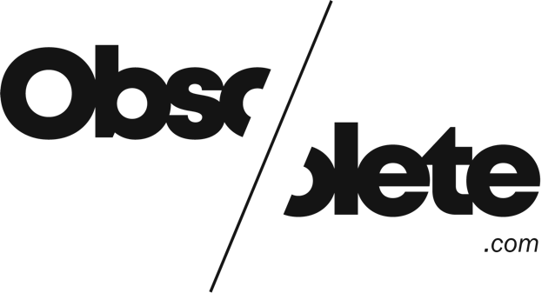

https://www.linkedin.com/posts/annie-hannah-shaw-a11958a8_virtualproduction-unrealengine-activity-7250176825606246400-Dm0Q?utm_source=share&utm_medium=member_desktop&rcm=ACoAAAAPzsUBDFXF4NzOPdllZyr9uuxdek8JKSM
‘Manchester can also be defined by its Travel to Work Area (TTWA), which is the area within which three-quarters of its residents both live and work. Manchester’s is the largest TTWA by population in the UK after London’s.’ (Tether, 2022)
Middle Level Super Output Area (MSOA) unit of geographical analysis
Unpublished data from Manchester City Council (2024)
The Fifth Sector analysis of CI SIC code data from TheDataCIty, March 2025
Tether, op cit
Wayne Garvie, President of Sony Pictures Television, speaking on Radio 4’s Today programme on 28 March 2025
Sector totals rounded to reduce risk of disclosure, so may not total 14,742
Parsed via TheDataCity
Candidates who did not meet all the requirements above - i.e., that were not a legal entity, had no live LinkedIn Profile or no relationship with other organisations on the list - were not visualised on the SNA maps
An edge that lies on the shortest path between two nodes, and thus ‘brokers’ the relationship between them, has a high level of betweenness
Copyright in the original data belongs to Data City (www.thedatacity.com) and its licensors, © Data City 2025.

